***CHAPTER – I***

**INTRODUCTION**

Employee Management System is a web based technology in which an admin can add employees, assign projects and grant the leaves of the employee, adding with it we can see the project status and salary table. And on other hand the employee can view his profile apply for leave and view his project.

EMS we are using HTML5 and CSS3 front end and JavaScript, PHP for backend and MYSQL for database and WAMP/XAMP server for testing.

***CHAPTER – II***

**Objective**

Employee Management System is a web based technology in which an admin can add employees, assign projects and grant the leaves of the employee, adding with it we can see the project status and salary table. And on other hand the employee can view his profile apply for leave and view his project.

EMS we are using HTML5 and CSS3 front end and JavaScript, PHP for backend and MYSQL for database and WAMP/XAMP server for testing.

**ADMIN**

**Home:** Employee leader board is displayed.

**Add Employee:** Admin can add employee here.

**View Employee:** Admin can view, edit and Delete employee in this page.

**Assign Project:**  Admin can assign project for employee.

**Project Status:** Admin can assign project to employee in this page.

**Salary Table:** Admin can view the salary of the employees.

**Employee leave:** Admin can approve or cancel the leave.

**EMPLOYEE**

**Home:** Employee can see his due projects, his leave project, and salary status over here.

**My info:** An employee can view his own profile in this tab.

**My Project:** Employee can see the projects assigned to him.

**Apply Leave:** Employee can apply for leave and check his leave status.

***CHAPTER – III***

**PRELIMINARY**

**SYSTEM**

**ANALYSIS**

**3.1 EXISTING SYSTEM**

Presently, most of the functions in the EMS are done manually. Even though there are LAN connections and an administrator system, an automated system is not introduced. The owner records the details of the clients, login and logout time, cabin and has to calculate the amount. All these details are written in book. Also there is no special system to allocate cabins efficiently. The owner also has to calculate the total income of a day. The present system has following limitations:

* Limitations in report generations
* Manual recording consumes excess time
* Chances of error
* Difficulty in allocating cabins
* The retrieval of information regarding a client is time consuming
* Lack of billing system and manual calculation of daily income
* Repeated recording of frequent user details

Focusing on the drawbacks and inadequacies of the existing system, the new system is designed which could well replace the existing system.

***CHAPTER – IV***

**Software and**

**Hardware**

**Specification**

**HARDWARE REQUIREMENTS:**

|  |  |  |
| --- | --- | --- |
| Processor | : | Intel P-IV based system |
| Processor Speed | : | 2.0. GHz |
| RAM | : | 1GB |
| Hard Disk | : | 40GB to 80GB |

**SOFTWARE REQUIREMENTS:**

|  |  |  |
| --- | --- | --- |
| Database | : | MySQL |
| Server | : | Apache |
| Frontend | : | HTML |
| Scripting language | : | Java Script |
| IDE | : | Sublime |
| Technology | : | PHP |

**SYSTEM DEVELOPMENT lENVIRONMENT**

**1. HTML**

**WHAT IS HTML?**

To publish information for global distribution, one needs a university-understood language, a kind of publishing mother tongue that all computers may potentially understand. The publishing language used by the World Wide Web is HTML (Hyper Text Markup Language)

**HTML Gives Authors the Means To**

1. Publish online documents with headings, text, tables, list, photos etc.
2. Retrieve online information via hypertext links, at the click of a button
3. Design forms for conducting transactions with remote services, for use in searching information, making reservation, ordering products etc.;
4. Includes spreadsheets, video clips, sound clips, and other applications directly in the documents.

**Some HTML Tags**

<HTML> :Starting an HTML tag

<HEAD> : Creating a web page’s head

<TITLE> : Giving a web page ‘s body

</HEAD> : Ending a web pages head

</BODY> : Ending a web pages body

</HTML> :Ending a web page

<FORM> : Creating a HTML forms

<INPUT TYPE=BUTTON> : Creating a buttons

<INPUT TYPE=CHECKBOX> : Creating a checkboxes

<INPUT TYPE=SUBMIT> : Creating a submit button

<INPUT TYPE=TEXT> : Creating a text fields

**HTML 4.0**

HTML 4.0 extends with mechanisms for style sheets, scripting, frames embedding objects, improved support for right to left and mixed direction texts, richer tables and enhancements to form, offering improved accessibilities for people with disability.

**2. INTRODUCTION TO JAVA SCRIPT**

**WHAT IS JAVA SCRIPT?**

JavaScript, originally supported by Netscape Navigator, is the most popular Web scripting language today. JavaScript lets you embed programs right in your Web pages and run these programs using the Web browser. You place these programs in a <SCRIPT> element. If you want the script to write directly to the Web page, place it in the <BODY> element.

**EX:** <HTML>

<HEAD>

<TITLE></TITLE>

</HEAD>

<BODY>

<SCRIPT LANGUAGE=”JavaScript”>

</SCRIPT>

</BODY></HTML>

**JAVASCRIPTS OBJECTS**

JavaScript is an object-oriented language. JavaScript comes with a number of predefined objects.

**Objects of the JavaScript**

1. Document: Corresponds to the current Web page’s body. Using this object, you have access to the HTML of the page itself, including the all links, images and anchors in it.
2. Form: Holds information about HTML forms in the current page.
3. Frame: Refers to a frame in the browser’s window.
4. History: Holds the records of sites the Web browser has visited before reaching the current page.
5. Location: Holds information about the location of the current web page.
6. Navigator: Refers to the browser itself, letting you determine what browser the user has.
7. Window: Refers to the current browser window.

**JAVASCRIPTS EVENTS**

Some of the events of JavaScript

1. on Change: Occurs when data in a control, like a text field, changes.
2. on Click: Occurs when an element is clicked.
3. on Focus: Occurs when an element gets the focus.
4. on Mouse Down: Occurs when a mouse button goes down.
5. on Reset: Occurs when the user clicks the reset button.

**JAVASCRIPTS FUNCTIONS**

**Declaration of function**

Syntax: function function name ()

{

…

…

}

Write these functions in <SCRIPT> tag.

1. **RDBMS CONCEPTS**
2. **DATA ABSTRACTION**

A major purpose of a database system is to provide users with an abstract view of the data. This system hides certain details of how the data is stored and maintained. However in order for the system to be usable, data must be retrieved efficiently. The efficiency lead to the design of complex data structure for the representation of data in the database. Certain complexity must be hidden from the database system users. This accomplished by defining several levels of abstraction at which the database may be viewed.

1. **CLASSIFICATION OF DATABASE**

There are 3 types of database approaches given below,

* 1. **Hierarchical Database:**

In this type of model data is represented in simple tree structured. The record at the top of three is known as root, the root may have any number of dependents. Each of these may have any number of low level dependents and so on up to any number of levels. The disadvantages of the approach are that no independent record occurrence can exist without it’s superior.

* 1. **Network Database:**

In a Network database, data is represented by Network structure. In this approach record occurrence can have any number of superiors as well as any number of immediate dependents thus allow many to many correspondence directly than an hierarchical approach. The main disadvantage of the Network model is data representation is very complex resulting in complexity of the DML (Data Manipulation Language).

* 1. **Relational Database:**

The Relational model represents data and relationships among data by a collection of tables each of which has a number of columns with unique names.

1. **THE SQL LANGUAGE**

SQL is a language for relational database. SQL is a non-procedural i.e., when we use SQL we specify what we want to be done not how to do it.

**Features of SQL**

1. SQL is an interactive query language.
2. SQL is a database administration language.
3. SQL is a database programming language.
4. SQL is a client/server language.
5. SQL is a distributed database language.
6. SQL is a database gateway language.

**Basic SQL Commands**

* Data Definition Language commands (DDL)
* Data Manipulation Language commands (DML)
* Transaction Control Language commands (TCL)
* Data control Language commands (DCL)

**PHP**

* PHP is an acronym for "PHP: Hypertext Preprocessor"
* PHP is a widely-used, open source scripting language
* PHP scripts are executed on the server
* PHP is free to download and use

## What is a PHP File?

* PHP files can contain text, HTML, CSS, JavaScript, and PHP code
* PHP code are executed on the server, and the result is returned to the browser as plain HTML
* PHP files have extension ".php"

## What Can PHP Do?

* PHP can generate dynamic page content
* PHP can create, open, read, write, delete, and close files on the server
* PHP can collect form data
* PHP can send and receive cookies
* PHP can add, delete, modify data in your database
* PHP can be used to control user-access
* PHP can encrypt data

With PHP you are not limited to output HTML. You can output images, PDF files, and even Flash movies. You can also output any text, such as XHTML and XML.

***CHAPTER – V***

**Detail**

**SYSTEM**

**ANALYSIS**

* + The entire system is projected with a physical diagram which specifics the actual storage parameters that are physically necessary for any database to be stored on to the disk. The overall systems existential idea is derived from this diagram.
  + The relation upon the system is structure through a conceptual ER-Diagram, which not only specifics the existential entities but also the standard relations through which the system exists and the cardinalities that are necessary for the system state to continue.
  + The content level DFD is provided to have an idea of the functional inputs and outputs that are achieved through the system. The system depicts the input and output standards at the high level of the systems existence.

1. **DFD**

**0 level dfd**

0 level In the Zero Level the whole system is shown as a single process.

* No data stores are shown.
* Inputs to the overall system are shown together with data sources (as External entities).
* Outputs from the overall system are shown together with their destinations (as External entities).

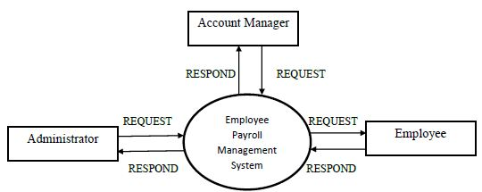

**1st level**

The First Level DFD gives the overview of the whole system identifying the major system processes and data flow. This level focuses on the single process that is drawn in the context diagram by ‘Zooming in’ on its contents and illustrates what it does in more detail.

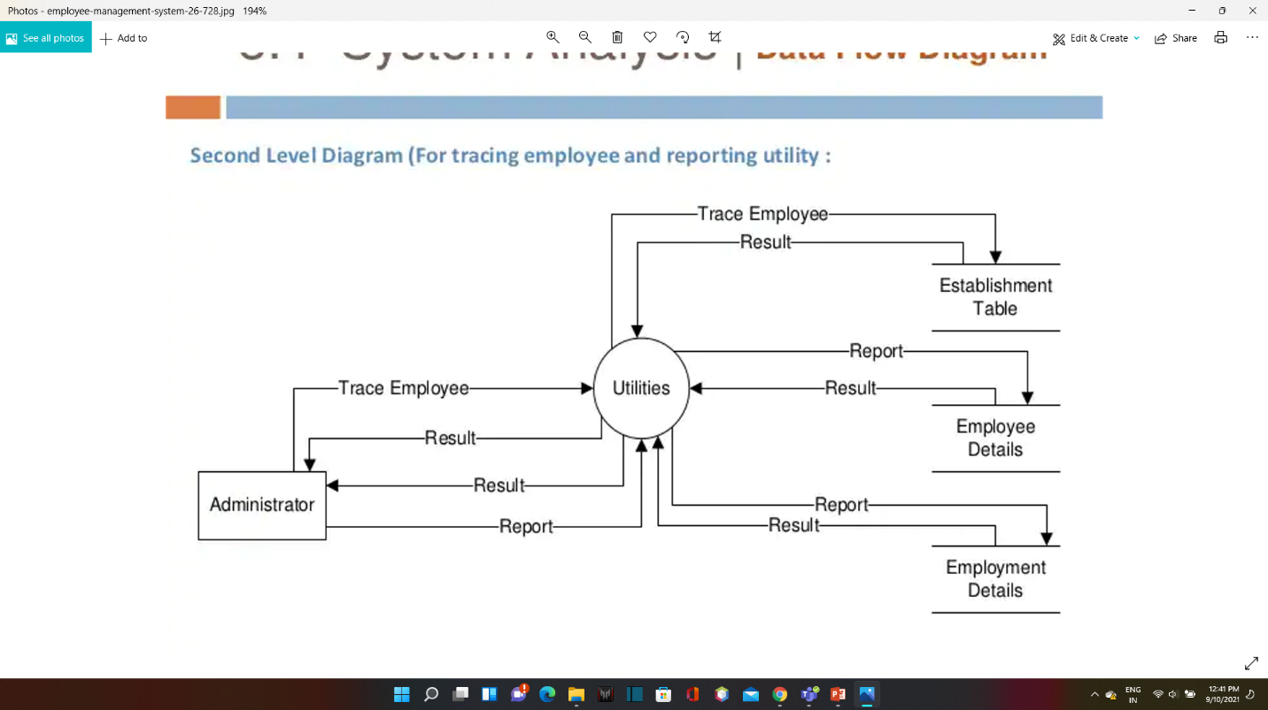

**2. Unified Modeling Language Diagrams(UML):**

* + The unified modeling language allows the software engineer to express an analysis model using the modeling notation that is governed by a set of syntactic semantic and pragmatic rules.
  + A UML system is represented using five different views that describe the system from distinctly different perspective. Each view is defined by a set of diagram, which is as follows.

**User Model View**

* + 1. This view represents the system from the users perspective.
    2. The analysis representation describes a usage scenario from the end-users perspective**.**

**Structural model view**

◆In this model the data and functionality are arrived from inside the system.

◆ This model view models the static structures.

**Behavioral Model View**

◆ It represents the dynamic of behavioral as parts of the system, depicting the interactions of collection between various structural elements described in the user model and structural model view.

**Implementation Model View**

* + In this the structural and behavioral as parts of the system are represented as they are to be built.

**Environmental Model View**

In this the structural and behavioral aspects of the environment in which the system is to be implemented are represented.

UML is specifically constructed through two different domains they are

* + UML Analysis modeling, which focuses on the user model and structural model views of the system?
  + UML design modeling, which focuses on the behavioral modeling, implementation modeling and environmental model views**.**

**Use Case**

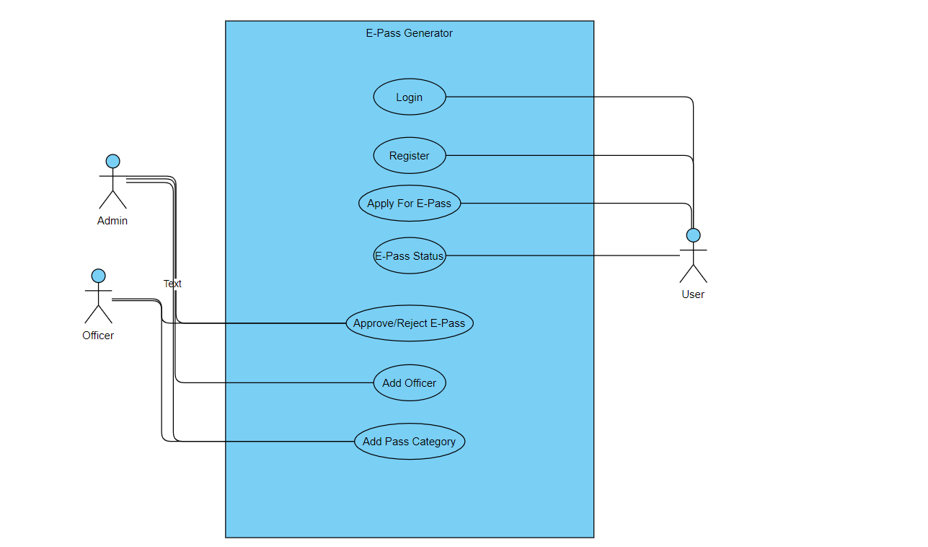

#### ENTITY-RELATIONSHIP Diagrams

E-R (Entity-Relationship) Diagram is used to represents the relationship between entities in the table.

## The symbols used in E-R diagrams are:

SYMBOL PURPOSE

Represents Entity sets.

Represent attributes.

Represent Relationship Sets.

Line represents flow

Structured analysis is a set of tools and techniques that the analyst.

To develop a new kind of a system:

The traditional approach focuses on the cost benefit and feasibility analysis, Project management, and hardware and software selection a personal considerations.

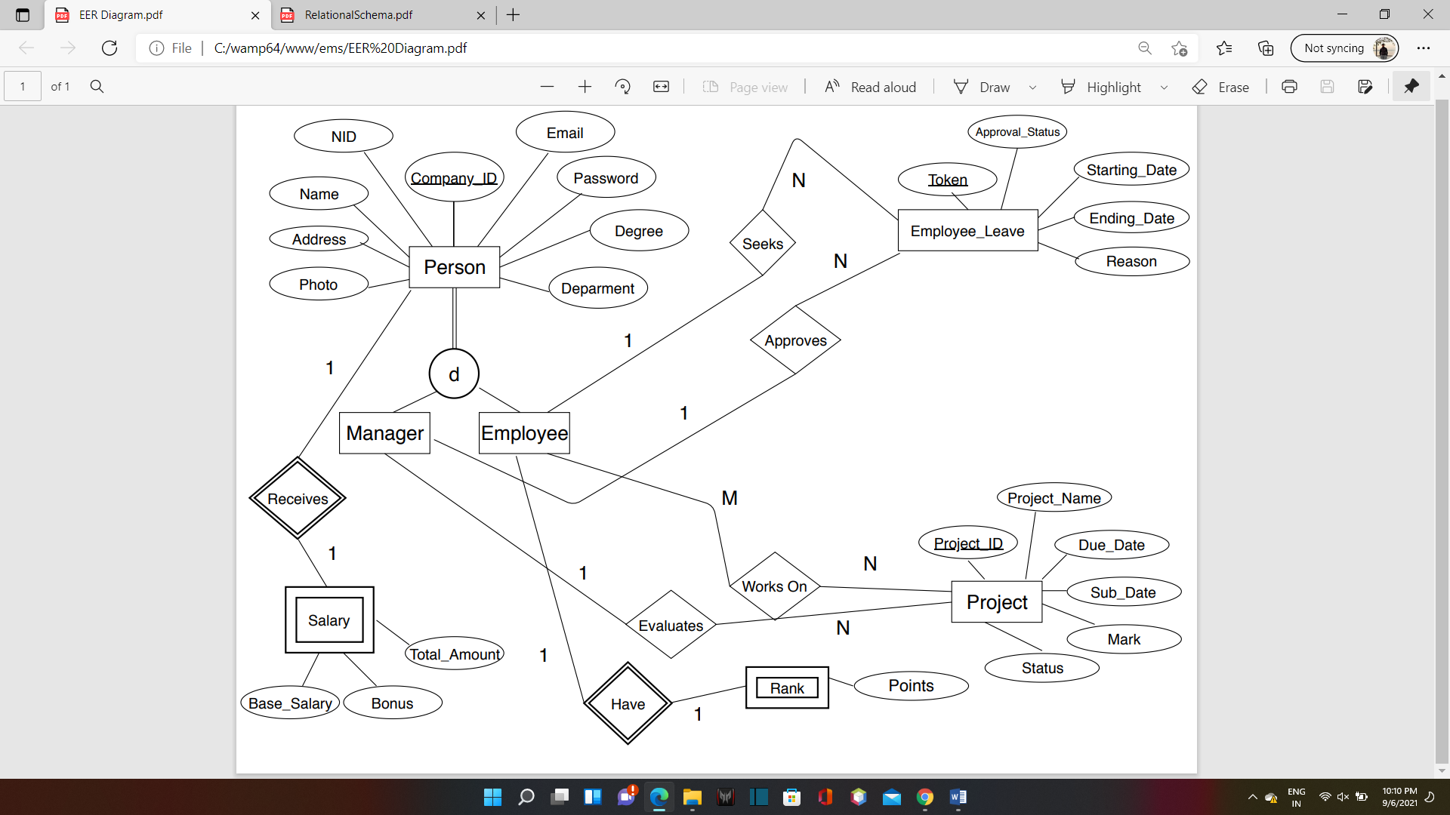

***CHAPTER – VI***

**Database**

**design**

The data in the system has to be stored and retrieved from database. Designing the database is part of system design. Data elements and data structures to be stored have been identified at analysis stage. They are structured and put together to design the data storage and retrieval system.

A database is a collection of interrelated data stored with minimum redundancy to serve many users quickly and efficiently. The general objective is to make database access easy, quick, inexpensive and flexible for the user. Relationships are established between the data items and unnecessary data items are removed. Normalization is done to get an internal consistency of data and to have minimum redundancy and maximum stability. This ensures minimizing data storage required, minimizing chances of data inconsistencies and optimizing for updates. The MS Access database has been chosen for developing the relevant databases.

**Employee Management System Project (EMS) contains 6 MySQL tables :**

**1)alogin**

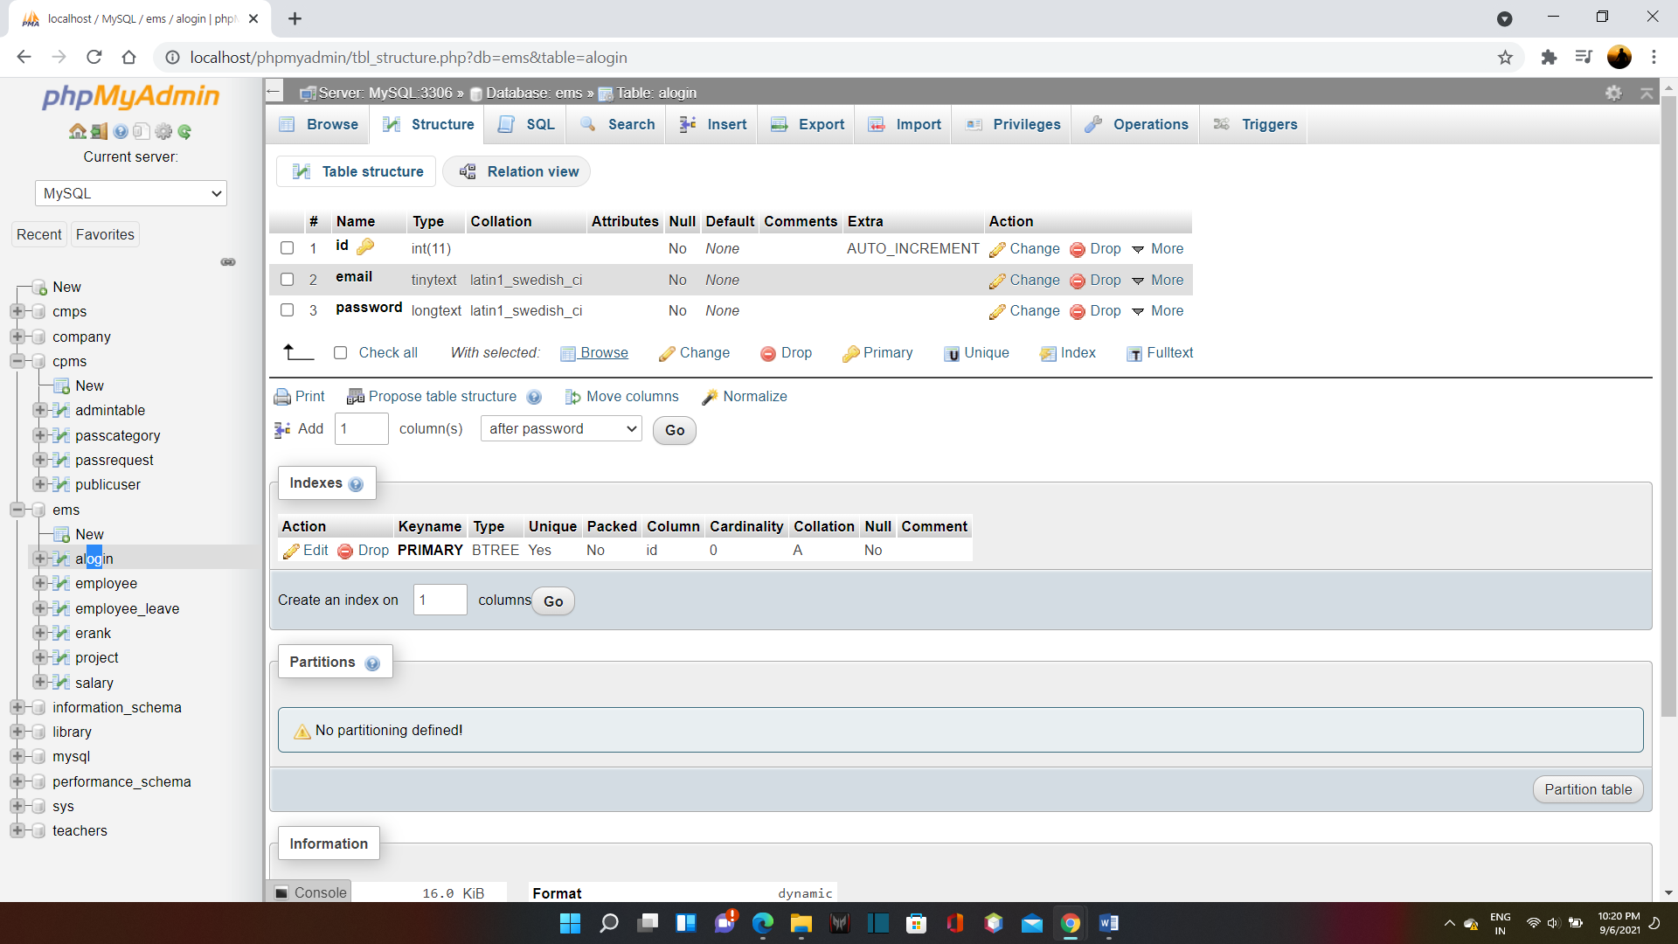

**2)employee**

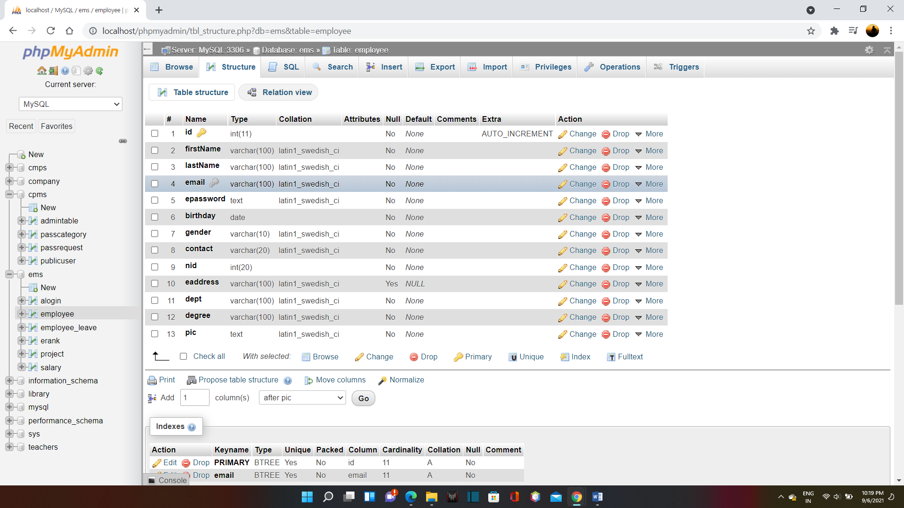

**3)employee_leave**

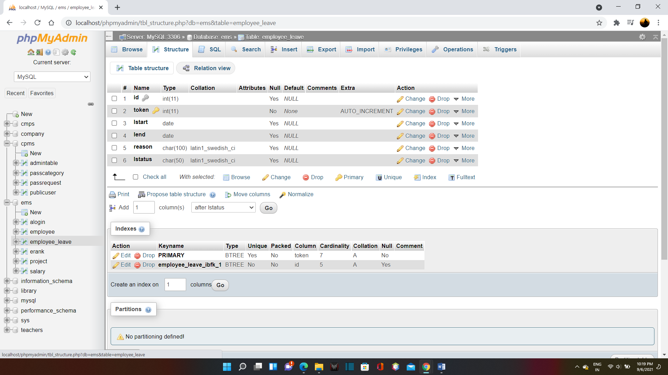

**4)erank**

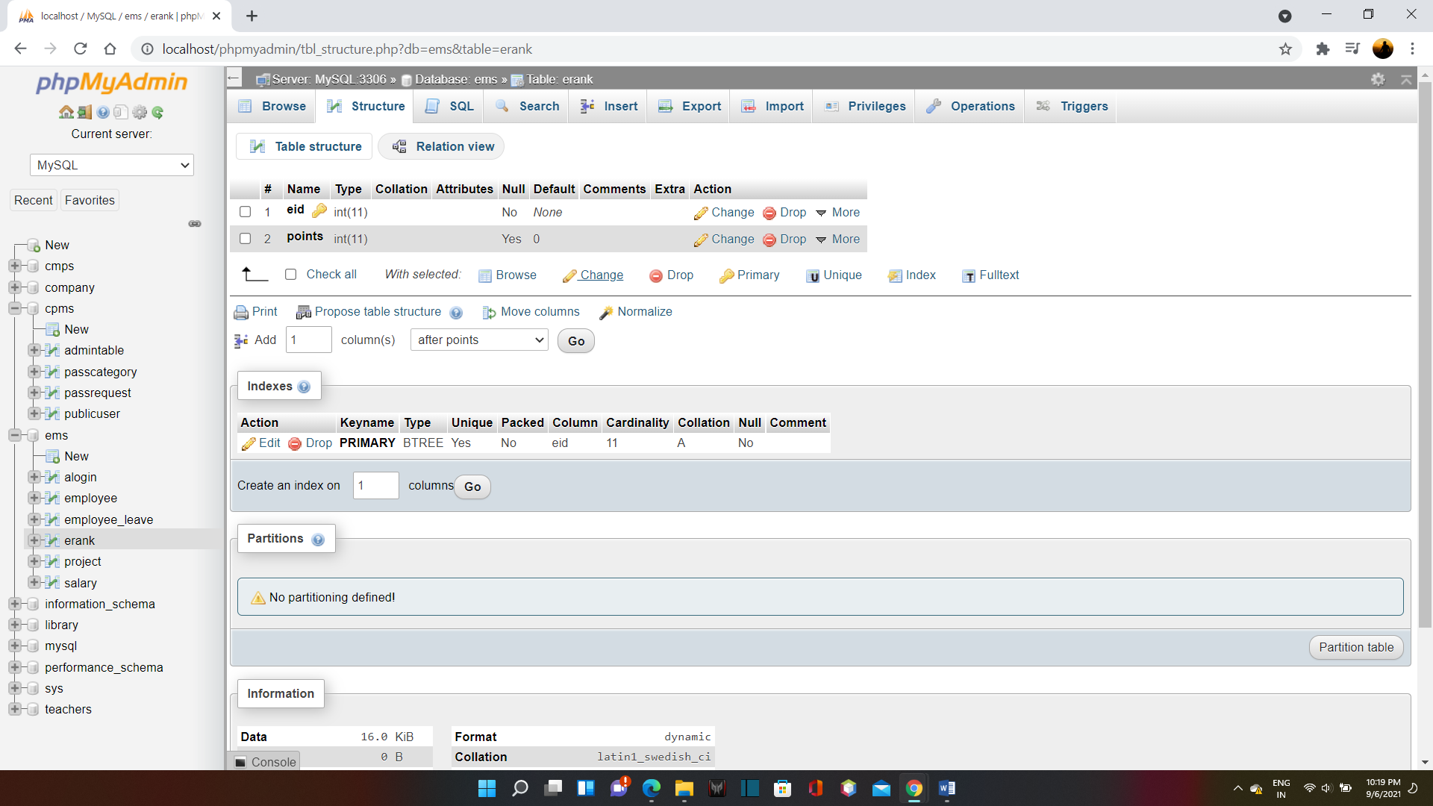

**4)project**

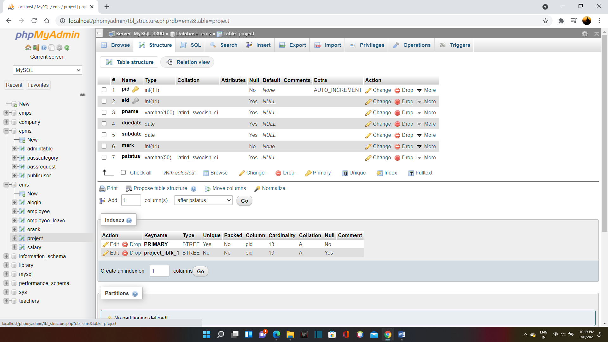

**5)salary**

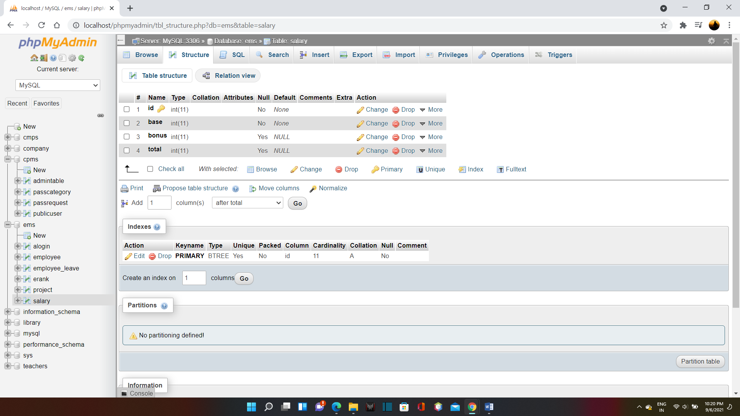

***CHAPTER – VII***

**Coding and design**

**Index.html**

<!DOCTYPE html>

<html>

<head>

<title>CROWN Corporation</title>

<link href="https://fonts.googleapis.com/css?family=Lobster|Montserrat" rel="stylesheet">

<link rel="stylesheet" type="text/css" href="styleindex.css">

</head>

<body>

<header>

<nav>

<h1>CROWN Corp.</h1>

<ul id="navli">

<li><a class="homered" href="index.html">HOME</a></li>

<li><a class="homeblack" href="#">ABOUT US</a></li>

<li><a class="homeblack" href="contact.html">CONTACT</a></li>

<li><a class="homeblack" href="elogin.html">LOG IN</a></li>

</ul>

</nav>

</header>

<div class="divider"></div>

<div id="divimg">

</div>

<img src="hero-banner.png" style="float: left; margin-right: 100px; margin-top: 35px; margin-left: 70px">

<div style="margin-top: 175px">

<h1 style="font-family: 'Lobster', cursive; font-weight: 200; font-size: 50px; margin-top: 100px; text-align: center;">Welcome to CROWN Corp.</h1>

<p style="font-family: 'Montserrat', sans-serif; font-size: 30px ; text-align: center;">Your One Stop Soloution</p>

</div>

</body>

</html>

**Aboutus.html**

<!DOCTYPE html>

<html>

<head>

<title>About Us | CROWN Corporation</title>

<link rel="stylesheet" type="text/css" href="style.css">

<link href="https://fonts.googleapis.com/css?family=Lobster|Montserrat" rel="stylesheet">

</head>

<body>

<header>

<nav>

<h1>CROWN Corp.</h1>

<ul id="navli">

<li><a class="homeblack" href="index.html">HOME</a></li>

<li><a class="homered" href="aboutus.html">ABOUT US</a></li>

<li><a class="homeblack" href="contact.html">CONTACT</a></li>

<li><a class="homeblack" href="elogin.html">LOG IN</a></li>

</ul>

</nav>

</header>

<div class="divider"></div>

<p style="font-family: Montserrat ; text-align: center; font-size: 40px">Group Members</p>

<div style="float: left; width: 33%">

<p style="text-align: center;"><img src="process/images/no.jpg" alt="Avatar" style="width:250px"></p>

<h2 style="text-align: center; font-family:Montserrat ">Mehadi Hassan</h2>

</div>

<div style="float: left; width: 33%">

<p style="text-align: center;"><img src="process/images/test.jpg" alt="Avatar" style="width:250px"></p>

<h2 style="text-align: center; font-family:Montserrat ">Shoaib Ahmed Dipu</h2>

</div>

<div style="float: left; width: 33%">

<p style="text-align: center;"><img src="process/images/no.jpg" alt="Avatar" style="width:250px"></p>

<h2 style="text-align: center; font-family:Montserrat ">Shemonto Das</h2>

</div>

</div>

</body>

</html>

**Addemp.php**

<!DOCTYPE html>

<html>

<head>

<!-- Title Page-->

<title>Add Employee | Admin Panel</title>

<!-- Icons font CSS-->

<link href="vendor/mdi-font/css/material-design-iconic-font.min.css" rel="stylesheet" media="all">

<link href="vendor/font-awesome-4.7/css/font-awesome.min.css" rel="stylesheet" media="all">

<!-- Font special for pages-->

<link href="https://fonts.googleapis.com/css?family=Roboto:100,100i,300,300i,400,400i,500,500i,700,700i,900,900i" rel="stylesheet">

<!-- Vendor CSS-->

<link href="vendor/select2/select2.min.css" rel="stylesheet" media="all">

<link href="vendor/datepicker/daterangepicker.css" rel="stylesheet" media="all">

<!-- Main CSS-->

<link href="css/main.css" rel="stylesheet" media="all">

</head>

<body>

<header>

<nav>

<h1>CROWN Corp.</h1>

<ul id="navli">

<li><a class="homeblack" href="aloginwel.php">HOME</a></li>

<li><a class="homered" href="addemp.php">Add Employee</a></li>

<li><a class="homeblack" href="viewemp.php">View Employee</a></li>

<li><a class="homeblack" href="assign.php">Assign Project</a></li>

<li><a class="homeblack" href="assignproject.php">Project Status</a></li>

<li><a class="homeblack" href="salaryemp.php">Salary Table</a></li>

<li><a class="homeblack" href="empleave.php">Employee Leave</a></li>

<li><a class="homeblack" href="alogin.html">Log Out</a></li>

</ul>

</nav>

</header>

<div class="divider"></div>

<div class="page-wrapper bg-blue p-t-100 p-b-100 font-robo">

<div class="wrapper wrapper--w680">

<div class="card card-1">

<div class="card-heading"></div>

<div class="card-body">

<h2 class="title">Registration Info</h2>

<form action="process/addempprocess.php" method="POST" enctype="multipart/form-data">

<div class="row row-space">

<div class="col-2">

<div class="input-group">

<input class="input--style-1" type="text" placeholder="First Name" name="firstName" required="required">

</div>

</div>

<div class="col-2">

<div class="input-group">

<input class="input--style-1" type="text" placeholder="Last Name" name="lastName" required="required">

</div>

</div>

</div>

<div class="input-group">

<input class="input--style-1" type="email" placeholder="Email" name="email" required="required">

</div>

<p>Birthday</p>

<div class="row row-space">

<div class="col-2">

<div class="input-group">

<input class="input--style-1" type="date" placeholder="BIRTHDATE" name="birthday" required="required">

</div>

</div>

<div class="col-2">

<div class="input-group">

<div class="rs-select2 js-select-simple select--no-search">

<select name="gender">

<option disabled="disabled" selected="selected">GENDER</option>

<option value="Male">Male</option>

<option value="Female">Female</option>

<option value="Other">Other</option>

</select>

<div class="select-dropdown"></div>

</div>

</div>

</div>

</div>

<div class="input-group">

<input class="input--style-1" type="number" placeholder="Contact Number" name="contact" required="required" >

</div>

<div class="input-group">

<input class="input--style-1" type="number" placeholder="NID" name="nid" required="required">

</div>

<div class="input-group">

<input class="input--style-1" type="text" placeholder="Address" name="address" required="required">

</div>

<div class="input-group">

<input class="input--style-1" type="text" placeholder="Department" name="dept" required="required">

</div>

<div class="input-group">

<input class="input--style-1" type="text" placeholder="Degree" name="degree" required="required">

</div>

<div class="input-group">

<input class="input--style-1" type="number" placeholder="Salary" name="salary">

</div>

<div class="input-group">

<input class="input--style-1" type="file" placeholder="file" name="file">

</div>

<div class="p-t-20">

<button class="btn btn--radius btn--green" type="submit">Submit</button>

</div>

</form>

</div>

</div>

</div>

</div>

<!-- Jquery JS-->

<script src="vendor/jquery/jquery.min.js"></script>

<!-- Vendor JS-->

<script src="vendor/select2/select2.min.js"></script>

<script src="vendor/datepicker/moment.min.js"></script>

<script src="vendor/datepicker/daterangepicker.js"></script>

<!-- Main JS-->

<script src="js/global.js"></script>

</body>

</html>

<!-- end document-->

**Alogin.html**

<!DOCTYPE html>

<html>

<head>

<title>Log In | CROWN Corporation</title>

<link rel="stylesheet" type="text/css" href="stylelogin.css">

</head>

<body>

<header>

<nav>

<h1>CROWN Corp.</h1>

<ul id="navli">

<li><a class="homeblack" href="index.html">HOME</a></li>

<li><a class="homeblack" href="elogin.html">Employee Login</a></li>

<li><a class="homered" href="alogin.html">Admin Login</a></li>

</ul>

</nav>

</header>

<div class="divider"></div>

<div class="loginbox">

<img src="assets/admin.png" class="avatar">

<h1>Login Here</h1>

<form action="process/aprocess.php" method="POST">

<p>Email</p>

<input type="text" name="mailuid" placeholder="Enter Email Address" required="required">

<p>Password</p>

<input type="password" name="pwd" placeholder="Enter Password" required="required">

<input type="submit" name="login-submit" value="Login">

</form>

</div>

</body>

</html>

**Aloginwel.php**

<?php

require_once ('process/dbh.php');

$sql = "SELECT id, firstName, lastName, points FROM employee, erank WHERE erank.eid = employee.id order by erank.points desc";

$result = mysqli_query($conn, $sql);

?>

<html>

<head>

<title>Admin Panel | CROWN Corporation</title>

<link rel="stylesheet" type="text/css" href="styleemplogin.css">

</head>

<body>

<header>

<nav>

<h1>CROWN Corp.</h1>

<ul id="navli">

<li><a class="homered" href="aloginwel.php">HOME</a></li>

<li><a class="homeblack" href="addemp.php">Add Employee</a></li>

<li><a class="homeblack" href="viewemp.php">View Employee</a></li>

<li><a class="homeblack" href="assign.php">Assign Project</a></li>

<li><a class="homeblack" href="assignproject.php">Project Status</a></li>

<li><a class="homeblack" href="salaryemp.php">Salary Table</a></li>

<li><a class="homeblack" href="empleave.php">Employee Leave</a></li>

<li><a class="homeblack" href="alogin.html">Log Out</a></li>

</ul>

</nav>

</header>

<div class="divider"></div>

<div id="divimg">

<h2 style="font-family: 'Montserrat', sans-serif; font-size: 25px; text-align: center;">Empolyee Leaderboard </h2>

<table>

<tr bgcolor="#000">

<th align = "center">Seq.</th>

<th align = "center">Emp. ID</th>

<th align = "center">Name</th>

<th align = "center">Points</th>

</tr>

<?php

$seq = 1;

while ($employee = mysqli_fetch_assoc($result)) {

echo "<tr>";

echo "<td>".$seq."</td>";

echo "<td>".$employee['id']."</td>";

echo "<td>".$employee['firstName']." ".$employee['lastName']."</td>";

echo "<td>".$employee['points']."</td>";

$seq+=1;

}

?>

</table>

<div class="p-t-20">

<button class="btn btn--radius btn--green" type="submit" style="float: right; margin-right: 60px"><a href="reset.php" style="text-decoration: none; color: white"> Reset Points</button>

</div>

</div>

</body>

</html>

**Applyleave.php**

<?php

$id = (isset($_GET['id']) ? $_GET['id'] : '');

require_once ('process/dbh.php');

$sql = "SELECT * FROM employee where id = '$id'";

$result = mysqli_query($conn, $sql);

$employee = mysqli_fetch_array($result);

$empName = ($employee['firstName']);

//echo "$id";

?>

<html>

<head>

<title>Apply Leave | Employee Panel | CROWN Corporation</title>

<link rel="stylesheet" type="text/css" href="styleapply.css">

</head>

<body bgcolor="#F0FFFF">

<header>

<nav>

<h1>CROWN Corp.</h1>

<ul id="navli">

<li><a class="homeblack" href="eloginwel.php?id=<?php echo $id?>"">HOME</a></li>

<li><a class="homeblack" href="myprofile.php?id=<?php echo $id?>"">My Profile</a></li>

<li><a class="homeblack" href="empproject.php?id=<?php echo $id?>"">My Projects</a></li>

<li><a class="homered" href="applyleave.php?id=<?php echo $id?>"">Apply Leave</a></li>

<li><a class="homeblack" href="elogin.html">Log Out</a></li>

</ul>

</nav>

</header>

<div class="divider"></div>

<div class="page-wrapper bg-blue p-t-100 p-b-100 font-robo">

<div class="wrapper wrapper--w680">

<div class="card card-1">

<div class="card-heading"></div>

<div class="card-body">

<h2 class="title">Apply Leave Form</h2>

<form action="process/applyleaveprocess.php?id=<?php echo $id?>" method="POST">

<div class="input-group">

<input class="input--style-1" type="text" placeholder="Reason" name="reason">

</div>

<div class="row row-space">

<div class="col-2">

<p>Start Date</p>

<div class="input-group">

<input class="input--style-1" type="date" placeholder="start" name="start">

</div>

</div>

<div class="col-2">

<p>End Date</p>

<div class="input-group">

<input class="input--style-1" type="date" placeholder="end" name="end">

</div>

</div>

</div>

<div class="p-t-20">

<button class="btn btn--radius btn--green" type="submit">Submit</button>

</div>

</form>

</div>

</div>

</div>

</div>

<table>

<tr>

<th align = "center">Emp. ID</th>

<th align = "center">Name</th>

<th align = "center">Start Date</th>

<th align = "center">End Date</th>

<th align = "center">Total Days</th>

<th align = "center">Reason</th>

<th align = "center">Status</th>

</tr>

<?php

$sql = "Select employee.id, employee.firstName, employee.lastName, employee_leave.lstart, employee_leave.lend, employee_leave.reason, employee_leave.lstatus From employee, employee_leave Where employee.id = $id and employee_leave.id = $id order by employee_leave.token";

$result = mysqli_query($conn, $sql);

while ($employee = mysqli_fetch_assoc($result)) {

$date1 = new DateTime($employee['lstart']);

$date2 = new DateTime($employee['lend']);

$interval = $date1->diff($date2);

$interval = $date1->diff($date2);

echo "<tr>";

echo "<td>".$employee['id']."</td>";

echo "<td>".$employee['firstName']." ".$employee['lastName']."</td>";

echo "<td>".$employee['lstart']."</td>";

echo "<td>".$employee['lend']."</td>";

echo "<td>".$interval->days."</td>";

echo "<td>".$employee['reason']."</td>";

echo "<td>".$employee['lstatus']."</td>";

}

?>

</table>

</body>

</html>

**Approve.php**

<?php

//including the database connection file

include("process/dbh.php");

//getting id of the data from url

$id = $_GET['id'];

$token = $_GET['token'];

//deleting the row from table

$result = mysqli_query($conn, "UPDATE employee_leave SET lstatus='Approved' WHERE id = $id AND token = $token;");

//redirecting to the display page (index.php in our case)

header("Location:empleave.php");

?>

**Assign.php**

<!DOCTYPE html>

<html>

<head>

<!-- Title Page-->

<title>Assign Project | Admin Panel</title>

<!-- Icons font CSS-->

<link href="vendor/mdi-font/css/material-design-iconic-font.min.css" rel="stylesheet" media="all">

<link href="vendor/font-awesome-4.7/css/font-awesome.min.css" rel="stylesheet" media="all">

<!-- Font special for pages-->

<link href="https://fonts.googleapis.com/css?family=Roboto:100,100i,300,300i,400,400i,500,500i,700,700i,900,900i" rel="stylesheet">

<!-- Vendor CSS-->

<link href="vendor/select2/select2.min.css" rel="stylesheet" media="all">

<link href="vendor/datepicker/daterangepicker.css" rel="stylesheet" media="all">

<!-- Main CSS-->

<link href="css/main.css" rel="stylesheet" media="all">

</head>

<body>

<header>

<nav>

<h1>CROWN Corp.</h1>

<ul id="navli">

<li><a class="homeblack" href="aloginwel.php">HOME</a></li>

<li><a class="homeblack" href="addemp.php">Add Employee</a></li>

<li><a class="homeblack" href="viewemp.php">View Employee</a></li>

<li><a class="homered" href="assign.php">Assign Project</a></li>

<li><a class="homeblack" href="assignproject.php">Project Status</a></li>

<li><a class="homeblack" href="salaryemp.php">Salary Table</a></li>

<li><a class="homeblack" href="empleave.php">Employee Leave</a></li>

<li><a class="homeblack" href="alogin.html">Log Out</a></li>

</ul>

</nav>

</header>

<div class="divider"></div>

<div class="page-wrapper bg-blue p-t-100 p-b-100 font-robo">

<div class="wrapper wrapper--w680">

<div class="card card-1">

<div class="card-heading"></div>

<div class="card-body">

<h2 class="title">Assign Project</h2>

<form action="process/assignp.php" method="POST" enctype="multipart/form-data">

<div class="input-group">

<input class="input--style-1" type="text" placeholder="Employee ID" name="eid" required="required">

</div>

<div class="input-group">

<input class="input--style-1" type="text" placeholder="Project Name" name="pname" required="required">

</div>

<div class="row row-space">

<div class="col-2">

<div class="input-group">

<input class="input--style-1" type="date" placeholder="date" name="duedate" required="required">

</div>

</div>

</div>

<div class="p-t-20">

<button class="btn btn--radius btn--green" type="submit">Assign</button>

</div>

</form>

</div>

</div>

</div>

</div>

<!-- Jquery JS-->

<script src="vendor/jquery/jquery.min.js"></script>

<!-- Vendor JS-->

<script src="vendor/select2/select2.min.js"></script>

<script src="vendor/datepicker/moment.min.js"></script>

<script src="vendor/datepicker/daterangepicker.js"></script>

<!-- Main JS-->

<script src="js/global.js"></script>

</body>

</html>

<!-- end document-->

**Assignproject.php**

<?php

require_once ('process/dbh.php');

$sql = "SELECT * from `project` order by subdate desc";

//echo "$sql";

$result = mysqli_query($conn, $sql);

?>

<html>

<head>

<title>Project Status | Admin Panel | CROWN Corporation</title>

<link rel="stylesheet" type="text/css" href="styleview.css">

</head>

<body>

<header>

<nav>

<h1>CROWN Corp.</h1>

<ul id="navli">

<li><a class="homeblack" href="aloginwel.php">HOME</a></li>

<li><a class="homeblack" href="addemp.php">Add Employee</a></li>

<li><a class="homeblack" href="viewemp.php">View Employee</a></li>

<li><a class="homeblack" href="assign.php">Assign Project</a></li>

<li><a class="homered" href="assignproject.php">Project Status</a></li>

<li><a class="homeblack" href="salaryemp.php">Salary Table</a></li>

<li><a class="homeblack" href="empleave.php">Employee Leave</a></li>

<li><a class="homeblack" href="alogin.html">Log Out</a></li>

</ul>

</nav>

</header>

<div class="divider"></div>

<table>

<tr>

<th align = "center">Project ID</th>

<th align = "center">Emp. ID</th>

<th align = "center">Project Name</th>

<th align = "center">Due Date</th>

<th align = "center">Submission Date</th>

<th align = "center">Mark</th>

<th align = "center">Status</th>

<th align = "center">Option</th>

</tr>

<?php

while ($employee = mysqli_fetch_assoc($result)) {

echo "<tr>";

echo "<td>".$employee['pid']."</td>";

echo "<td>".$employee['eid']."</td>";

echo "<td>".$employee['pname']."</td>";

echo "<td>".$employee['duedate']."</td>";

echo "<td>".$employee['subdate']."</td>";

echo "<td>".$employee['mark']."</td>";

echo "<td>".$employee['pstatus']."</td>";

echo "<td><a href=\"mark.php?id=$employee[eid]&pid=$employee[pid]\">Mark</a>";

}

?>

</table>

</body>

</html>

**Cancel.php**

<?php

//including the database connection file

include("process/dbh.php");

//getting id of the data from url

$id = $_GET['id'];

$token = $_GET['token'];

//deleting the row from table

$result = mysqli_query($conn, "UPDATE employee_leave SET lstatus='Cancelled' WHERE id=$id and token = $token");

//redirecting to the display page (index.php in our case)

header("Location:empleave.php");

?>

**Changepassemp.php**

<?php

require_once ('process/dbh.php');

$sql = "SELECT * FROM `employee` WHERE 1";

//echo "$sql";

$result = mysqli_query($conn, $sql);

if(isset($_POST['update']))

{

$id = $_POST['id'];

$old = $_POST['oldpass'];

$new = $_POST['newpass'];

$result = mysqli_query($conn, "select employee.epassword from employee WHERE id = $id");

$employee = mysqli_fetch_assoc($result);

if($old == $employee['epassword']){

$sql = "UPDATE employee SET epassword='$new' WHERE id = $id";

mysqli_query($conn, $sql);

echo ("<SCRIPT LANGUAGE='JavaScript'>

window.alert('Password Updated')

window.location.href='myprofile.php?id=$id';</SCRIPT>");

}

else{

echo ("<SCRIPT LANGUAGE='JavaScript'>

window.alert('Failed to Update Password')

window.location.href='javascript:history.go(-1)';

</SCRIPT>");

}

}

?>

<!-- <?php

$id = (isset($_GET['id']) ? $_GET['id'] : '');

$sql = "SELECT * from `employee` WHERE id=$id";

$result = mysqli_query($conn, $sql);

if($result){

while($res = mysqli_fetch_assoc($result)){

$old = $res['password'];

echo "$old";

}

}

?> -->

<html>

<head>

<title>Change Password | CROWN Corporation</title>

<!-- Icons font CSS-->

<link href="vendor/mdi-font/css/material-design-iconic-font.min.css" rel="stylesheet" media="all">

<link href="vendor/font-awesome-4.7/css/font-awesome.min.css" rel="stylesheet" media="all">

<!-- Font special for pages-->

<link href="https://fonts.googleapis.com/css?family=Roboto:100,100i,300,300i,400,400i,500,500i,700,700i,900,900i" rel="stylesheet">

<!-- Vendor CSS-->

<link href="vendor/select2/select2.min.css" rel="stylesheet" media="all">

<link href="vendor/datepicker/daterangepicker.css" rel="stylesheet" media="all">

<!-- Main CSS-->

<link href="css/main.css" rel="stylesheet" media="all">

</head>

<body>

<header>

<nav>

<h1>CROWN Corp.</h1>

<ul id="navli">

<li><a class="homeblack" href="eloginwel.php?id=<?php echo $id?>"">HOME</a></li>

<li><a class="homered" href="myprofile.php?id=<?php echo $id?>"">My Profile</a></li>

<li><a class="homeblack" href="applyleave.php?id=<?php echo $id?>"">Apply Leave</a></li>

<li><a class="homeblack" href="elogin.html">Log Out</a></li>

</ul>

</nav>

</header>

<div class="divider"></div>

<!-- <form id = "registration" action="edit.php" method="POST"> -->

<div class="page-wrapper bg-blue p-t-100 p-b-100 font-robo">

<div class="wrapper wrapper--w680">

<div class="card card-1">

<div class="card-heading"></div>

<div class="card-body">

<h2 class="title">Update Password</h2>

<form id = "registration" action="changepassemp.php" method="POST">

<div class="row row-space">

<div class="col-2">

<div class="input-group">

<p>Old Password</p>

<input class="input--style-1" type="Password" name = "oldpass" required >

</div>

</div>

<div class="col-2">

<div class="input-group">

<p>New Password</p>

<input class="input--style-1" type="Password" name="newpass" required>

</div>

</div>

</div>

<input type="hidden" name="id" id="textField" value="<?php echo $id;?>" required="required"><br><br>

<div class="p-t-20">

<button class="btn btn--radius btn--green" type="submit" name="update">Submit</button>

</div>

</form>

</div>

</div>

</div>

</body>

</html>

**Contact.html**

<!DOCTYPE html>

<html>

<head>

<title>Contact | CROWN Corporation</title>

<link rel="stylesheet" type="text/css" href="style.css">

<link rel="stylesheet" href="https://use.fontawesome.com/releases/v5.8.1/css/all.css" integrity="sha384-50oBUHEmvpQ+1lW4y57PTFmhCaXp0ML5d60M1M7uH2+nqUivzIebhndOJK28anvf" crossorigin="anonymous">

<link href="https://fonts.googleapis.com/css?family=Lobster|Montserrat" rel="stylesheet"

</head>

<body>

<header>

<nav>

<h1>CROWN Corp.</h1>

<ul id="navli">

<li><a class="homeblack" href="index.html">HOME</a></li>

<li><a class="homeblack" href="#">ABOUT US</a></li>

<li><a class="homered" href="contact.html">CONTACT</a></li>

<li><a class="homeblack" href="elogin.html">LOG IN</a></li>

</ul>

</nav>

</header>

<div class="divider"></div>

<div class="mapouter"><div class="gmap_canvas"><iframe width="1080" height="250" id="gmap_canvas" src="https://maps.google.com/maps?q=23.793630%2C%2090.406998&t=&z=17&ie=UTF8&iwloc=&output=embed" frameborder="0" scrolling="no" marginheight="0" marginwidth="0"></iframe>Google Maps Generator by <a href="https://www.embedgooglemap.net">embedgooglemap.net</a></div><style>.mapouter{position:relative;text-align:right;height:250px;width:2080px;}.gmap_canvas {overflow:hidden;background:none!important;height:250px;width:1080px;}</style></div>

<p style="font-family: Montserrat; text-align: center; font-size: 25px"><i class="fas fa-map-marked"></i> CROWN Corp.</p>

<p style="font-family: Montserrat; text-align: center; font-size: 25px"><i class="fas fa-address-book"></i> +8801234567891</p>

<p style="font-family: Montserrat; text-align: center; font-size: 25px"><i class="fas fa-envelope"></i> contact@CROWN.corp</p>

</body>

</html>

**Delete.php**

<?php

//including the database connection file

include("process/dbh.php");

//getting id of the data from url

$id = $_GET['id'];

//deleting the row from table

$result = mysqli_query($conn, "DELETE FROM employee WHERE id=$id");

//redirecting to the display page (index.php in our case)

header("Location:viewemp.php");

?>

**Edit.php**

<?php

require_once ('process/dbh.php');

$sql = "SELECT * FROM `employee` WHERE 1";

//echo "$sql";

$result = mysqli_query($conn, $sql);

if(isset($_POST['update']))

{

$id = mysqli_real_escape_string($conn, $_POST['id']);

$firstname = mysqli_real_escape_string($conn, $_POST['firstName']);

$lastname = mysqli_real_escape_string($conn, $_POST['lastName']);

$email = mysqli_real_escape_string($conn, $_POST['email']);

$birthday = mysqli_real_escape_string($conn, $_POST['birthday']);

$contact = mysqli_real_escape_string($conn, $_POST['contact']);

$address = mysqli_real_escape_string($conn, $_POST['address']);

$gender = mysqli_real_escape_string($conn, $_POST['gender']);

$nid = mysqli_real_escape_string($conn, $_POST['nid']);

$dept = mysqli_real_escape_string($conn, $_POST['dept']);

$degree = mysqli_real_escape_string($conn, $_POST['degree']);

//$salary = mysqli_real_escape_string($conn, $_POST['salary']);

// $result = mysqli_query($conn, "UPDATE `employee` SET `firstName`='$firstname',`lastName`='$lastname',`email`='$email',`password`='$email',`gender`='$gender',`contact`='$contact',`nid`='$nid',`salary`='$salary',`address`='$address',`dept`='$dept',`degree`='$degree' WHERE id=$id");

$result = mysqli_query($conn, "UPDATE employee SET firstName='".$firstname."',lastName='".$lastname."',email='".$email."',birthday='".$birthday."',gender='".$gender."',contact='".$contact."',nid=".$nid.",address='".$address."',dept='".$dept."',degree='".$degree."' WHERE id=$id");

echo ("<SCRIPT LANGUAGE='JavaScript'>

window.alert('Succesfully Updated')

window.location.href='viewemp.php';

</SCRIPT>");

}

?>

<?php

$id = (isset($_GET['id']) ? $_GET['id'] : '');

$sql = "SELECT * from `employee` WHERE id=$id";

$result = mysqli_query($conn, $sql);

if($result){

while($res = mysqli_fetch_assoc($result)){

$firstname = $res['firstName'];

$lastname = $res['lastName'];

$email = $res['email'];

$contact = $res['contact'];

$address = $res['eaddress'];

$gender = $res['gender'];

$birthday = $res['birthday'];

$nid = $res['nid'];

$dept = $res['dept'];

$degree = $res['degree'];

}

}

?>

<html>

<head>

<title>View Employee | Admin Panel | CROWN Corporation</title>

<!-- Icons font CSS-->

<link href="vendor/mdi-font/css/material-design-iconic-font.min.css" rel="stylesheet" media="all">

<link href="vendor/font-awesome-4.7/css/font-awesome.min.css" rel="stylesheet" media="all">

<!-- Font special for pages-->

<link href="https://fonts.googleapis.com/css?family=Roboto:100,100i,300,300i,400,400i,500,500i,700,700i,900,900i" rel="stylesheet">

<!-- Vendor CSS-->

<link href="vendor/select2/select2.min.css" rel="stylesheet" media="all">

<link href="vendor/datepicker/daterangepicker.css" rel="stylesheet" media="all">

<!-- Main CSS-->

<link href="css/main.css" rel="stylesheet" media="all">

</head>

<body>

<header>

<nav>

<h1>CROWN Corp.</h1>

<ul id="navli">

<li><a class="homeblack" href="index.html">HOME</a></li>

<li><a class="homeblack" href="addemp.php">Add Employee</a></li>

<li><a class="homered" href="viewemp.php">View Employee</a></li>

<li><a class="homeblack" href="elogin.html">Log Out</a></li>

</ul>

</nav>

</header>

<div class="divider"></div>

<!-- <form id = "registration" action="edit.php" method="POST"> -->

<div class="page-wrapper bg-blue p-t-100 p-b-100 font-robo">

<div class="wrapper wrapper--w680">

<div class="card card-1">

<div class="card-heading"></div>

<div class="card-body">

<h2 class="title">Update Employee Info</h2>

<form id = "registration" action="edit.php" method="POST">

<div class="row row-space">

<div class="col-2">

<div class="input-group">

<input class="input--style-1" type="text" name="firstName" value="<?php echo $firstname;?>" >

</div>

</div>

<div class="col-2">

<div class="input-group">

<input class="input--style-1" type="text" name="lastName" value="<?php echo $lastname;?>">

</div>

</div>

</div>

<div class="input-group">

<input class="input--style-1" type="email" name="email" value="<?php echo $email;?>">

</div>

<div class="row row-space">

<div class="col-2">

<div class="input-group">

<input class="input--style-1" type="text" name="birthday" value="<?php echo $birthday;?>">

</div>

</div>

<div class="col-2">

<div class="input-group">

<input class="input--style-1" type="text" name="gender" value="<?php echo $gender;?>">

</div>

</div>

</div>

<div class="input-group">

<input class="input--style-1" type="number" name="contact" value="<?php echo $contact;?>">

</div>

<div class="input-group">

<input class="input--style-1" type="number" name="nid" value="<?php echo $nid;?>">

</div>

<div class="input-group">

<input class="input--style-1" type="text" name="address" value="<?php echo $address;?>">

</div>

<div class="input-group">

<input class="input--style-1" type="text" name="dept" value="<?php echo $dept;?>">

</div>

<div class="input-group">

<input class="input--style-1" type="text" name="degree" value="<?php echo $degree;?>">

</div>

<input type="hidden" name="id" id="textField" value="<?php echo $id;?>" required="required"><br><br>

<div class="p-t-20">

<button class="btn btn--radius btn--green" type="submit" name="update">Submit</button>

</div>

</form>

</div>

</div>

</div>

</div>

<!-- Jquery JS-->

<!-- <script src="vendor/jquery/jquery.min.js"></script>

<script src="vendor/select2/select2.min.js"></script>

<script src="vendor/datepicker/moment.min.js"></script>

<script src="vendor/datepicker/daterangepicker.js"></script>

<script src="js/global.js"></script> -->

</body>

</html>

**elogin.html**

<!DOCTYPE html>

<html>

<head>

<title>Log In | CROWN Corporation</title>

<link rel="stylesheet" type="text/css" href="stylelogin.css">

</head>

<body>

<header>

<nav>

<h1>CROWN Corp.</h1>

<ul id="navli">

<li><a class="homeblack" href="index.html">HOME</a></li>

<li><a class="homered" href="elogin.html">Employee Login</a></li>

<li><a class="homeblack" href="alogin.html">Admin Login</a></li>

</ul>

</nav>

</header>

<div class="divider"></div>

<div class="loginbox">

<img src="assets/avatar.png" class="avatar">

<h1>Login Here</h1>

<form action="process/eprocess.php" method="POST">

<p>Email</p>

<input type="text" name="mailuid" placeholder="Enter Email Address" required="required">

<p>Password</p>

<input type="password" name="pwd" placeholder="Enter Password" required="required">

<input type="submit" name="login-submit" value="Login">

</form>

</div>

</body>

</html>

**Eloginwel.php**

<?php

$id = (isset($_GET['id']) ? $_GET['id'] : '');

require_once ('process/dbh.php');

$sql1 = "SELECT * FROM `employee` where id = '$id'";

$result1 = mysqli_query($conn, $sql1);

$employeen = mysqli_fetch_array($result1);

$empName = ($employeen['firstName']);

$sql = "SELECT id, firstName, lastName, points FROM employee, erank WHERE erank.eid = employee.id order by erank.points desc";

$sql1 = "SELECT pname, duedate FROM project WHERE eid = $id and pstatus = 'Due'";

$sql2 = "Select * From employee, employee_leave Where employee.id = $id and employee_leave.id = $id order by employee_leave.token";

$sql3 = "SELECT * FROM salary WHERE id = $id";

//echo "$sql";

$result = mysqli_query($conn, $sql);

$result1 = mysqli_query($conn, $sql1);

$result2 = mysqli_query($conn, $sql2);

$result3 = mysqli_query($conn, $sql3);

?>

<html>

<head>

<title>Employee Panel | CROWN Corporation</title>

<link rel="stylesheet" type="text/css" href="styleemplogin.css">

<link href="https://fonts.googleapis.com/css?family=Lobster|Montserrat" rel="stylesheet">

</head>

<body>

<header>

<nav>

<h1>CROWN Corp.</h1>

<ul id="navli">

<li><a class="homered" href="eloginwel.php?id=<?php echo $id?>"">HOME</a></li>

<li><a class="homeblack" href="myprofile.php?id=<?php echo $id?>"">My Profile</a></li>

<li><a class="homeblack" href="empproject.php?id=<?php echo $id?>"">My Projects</a></li>

<li><a class="homeblack" href="applyleave.php?id=<?php echo $id?>"">Apply Leave</a></li>

<li><a class="homeblack" href="elogin.html">Log Out</a></li>

</ul>

</nav>

</header>

<div class="divider"></div>

<div id="divimg">

<div>

<!-- <h2>Welcome <?php echo "$empName"; ?> </h2> -->

<h2 style="font-family: 'Montserrat', sans-serif; font-size: 25px; text-align: center;">Empolyee Leaderboard </h2>

<table>

<tr bgcolor="#000">

<th align = "center">Seq.</th>

<th align = "center">Emp. ID</th>

<th align = "center">Name</th>

<th align = "center">Points</th>

</tr>

<?php

$seq = 1;

while ($employee = mysqli_fetch_assoc($result)) {

echo "<tr>";

echo "<td>".$seq."</td>";

echo "<td>".$employee['id']."</td>";

echo "<td>".$employee['firstName']." ".$employee['lastName']."</td>";

echo "<td>".$employee['points']."</td>";

$seq+=1;

}

?>

</table>

<h2 style="font-family: 'Montserrat', sans-serif; font-size: 25px; text-align: center;">Due Projects</h2>

<table>

<tr>

<th align = "center">Project Name</th>

<th align = "center">Due Date</th>

</tr>

<?php

while ($employee1 = mysqli_fetch_assoc($result1)) {

echo "<tr>";

echo "<td>".$employee1['pname']."</td>";

echo "<td>".$employee1['duedate']."</td>";

}

?>

</table>

<h2 style="font-family: 'Montserrat', sans-serif; font-size: 25px; text-align: center;">Salary Status</h2>

<table>

<tr>

<th align = "center">Base Salary</th>

<th align = "center">Bonus</th>

<th align = "center">Total Salary</th>

</tr>

<?php

while ($employee = mysqli_fetch_assoc($result3)) {

echo "<tr>";

echo "<td>".$employee['base']."</td>";

echo "<td>".$employee['bonus']." %</td>";

echo "<td>".$employee['total']."</td>";

}

?>

</table>

<h2 style="font-family: 'Montserrat', sans-serif; font-size: 25px; text-align: center;">Leave Satus</h2>

<table>

<tr>

<th align = "center">Start Date</th>

<th align = "center">End Date</th>

<th align = "center">Total Days</th>

<th align = "center">Reason</th>

<th align = "center">Status</th>

</tr>

<?php

while ($employee = mysqli_fetch_assoc($result2)) {

$date1 = new DateTime($employee['lstart']);

$date2 = new DateTime($employee['lend']);

$interval = $date1->diff($date2);

$interval = $date1->diff($date2);

echo "<tr>";

echo "<td>".$employee['lstart']."</td>";

echo "<td>".$employee['lend']."</td>";

echo "<td>".$interval->days."</td>";

echo "<td>".$employee['reason']."</td>";

echo "<td>".$employee['lstatus']."</td>";

}

?>

</table>

<br>

<br>

<br>

<br>

<br>

</div>

</h2>

</div>

</body>

</html>

**Employeeleave.php**

<?php

require_once ('process/dbh.php');

//$sql = "SELECT * from `employee_leave`";

$sql = "Select employee.id, employee.firstName, employee.lastName, employee_leave.lstart, employee_leave.lend, employee_leave.reason, employee_leave.lstatus, employee_leave.token From employee, employee_leave Where employee.id = employee_leave.id order by employee_leave.token";

//echo "$sql";

$result = mysqli_query($conn, $sql);

?>

<html>

<head>

<title>Employee Leave | Admin Panel | CROWN Corporation</title>

<link rel="stylesheet" type="text/css" href="styleview.css">

</head>

<body>

<header>

<nav>

<h1>CROWN Corp.</h1>

<ul id="navli">

<li><a class="homeblack" href="aloginwel.php">HOME</a></li>

<li><a class="homeblack" href="addemp.php">Add Employee</a></li>

<li><a class="homeblack" href="viewemp.php">View Employee</a></li>

<li><a class="homeblack" href="assign.php">Assign Project</a></li>

<li><a class="homeblack" href="assignproject.php">Project Status</a></li>

<li><a class="homeblack" href="salaryemp.php">Salary Table</a></li>

<li><a class="homered" href="empleave.php">Employee Leave</a></li>

<li><a class="homeblack" href="alogin.html">Log Out</a></li>

</ul>

</nav>

</header>

<div class="divider"></div>

<div id="divimg">

<table>

<tr>

<th>Emp. ID</th>

<th>Token</th>

<th>Name</th>

<th>Start Date</th>

<th>End Date</th>

<th>Total Days</th>

<th>Reason</th>

<th>Status</th>

<th>Options</th>

</tr>

<?php

while ($employee = mysqli_fetch_assoc($result)) {

$date1 = new DateTime($employee['lstart']);

$date2 = new DateTime($employee['lend']);

$interval = $date1->diff($date2);

$interval = $date1->diff($date2);

//echo "difference " . $interval->days . " days ";

echo "<tr>";

echo "<td>".$employee['id']."</td>";

echo "<td>".$employee['token']."</td>";

echo "<td>".$employee['firstName']." ".$employee['lastName']."</td>";

echo "<td>".$employee['lstart']."</td>";

echo "<td>".$employee['lend']."</td>";

echo "<td>".$interval->days."</td>";

echo "<td>".$employee['reason']."</td>";

echo "<td>".$employee['lstatus']."</td>";

echo "<td><a href=\"approve.php?id=$employee[id]&token=$employee[token]\" onClick=\"return confirm('Are you sure you want to Approve the request?')\">Approve</a> | <a href=\"cancel.php?id=$employee[id]&token=$employee[token]\" onClick=\"return confirm('Are you sure you want to Canel the request?')\">Cancel</a></td>";

}

?>

</table>

</div>

</body>

</html>

**Employeeproject.php**

<?php

$id = (isset($_GET['id']) ? $_GET['id'] : '');

require_once ('process/dbh.php');

$sql = "SELECT * FROM `project` where eid = '$id'";

$result = mysqli_query($conn, $sql);

?>

<html>

<head>

<title>Employee Panel | CROWN Corporation</title>

<link rel="stylesheet" type="text/css" href="styleview.css">

</head>

<body>

<header>

<nav>

<h1>CROWN Corp.</h1>

<ul id="navli">

<li><a class="homeblack" href="eloginwel.php?id=<?php echo $id?>">HOME</a></li>

<li><a class="homeblack" href="myprofile.php?id=<?php echo $id?>">My Profile</a></li>

<li><a class="homered" href="empproject.php?id=<?php echo $id?>">My Projects</a></li>

<li><a class="homeblack" href="applyleave.php?id=<?php echo $id?>">Apply Leave</a></li>

<li><a class="homeblack" href="elogin.html">Log Out</a></li>

</ul>

</nav>

</header>

<div class="divider"></div>

<div id="divimg">

<table>

<tr>

<th align = "center">Project ID</th>

<th align = "center">Project Name</th>

<th align = "center">Due Date</th>

<th align = "center">Sub Date</th>

<th align = "center">Mark</th>

<th align = "center">Status</th>

<th align = "center">Option</th>

</tr>

<?php

while ($employee = mysqli_fetch_assoc($result)) {

echo "<tr>";

echo "<td>".$employee['pid']."</td>";

echo "<td>".$employee['pname']."</td>";

echo "<td>".$employee['duedate']."</td>";

echo "<td>".$employee['subdate']."</td>";

echo "<td>".$employee['mark']."</td>";

echo "<td>".$employee['pstatus']."</td>";

echo "<td><a href=\"psubmit.php?pid=$employee[pid]&id=$employee[eid]\">Submit</a>";

}

?>

</table>

</body>

</html>

**Mark.php**

<?php

require_once ('process/dbh.php');

$id = (isset($_GET['id']) ? $_GET['id'] : '');

$pid = (isset($_GET['pid']) ? $_GET['pid'] : '');

$sql = "SELECT pid, project.eid, pname, duedate, subdate, mark, points, firstName, lastName, base, bonus, total FROM project , erank ,employee, salary WHERE project.eid = $id AND pid = $pid";

//echo "$sql";

$result = mysqli_query($conn, $sql);

if(isset($_POST['update']))

{

$eid = mysqli_real_escape_string($conn, $_POST['eid']);

$pid = mysqli_real_escape_string($conn, $_POST['pid']);

$mark = mysqli_real_escape_string($conn, $_POST['mark']);

$points = mysqli_real_escape_string($conn, $_POST['points']);

$base = mysqli_real_escape_string($conn, $_POST['base']);

$bonus = mysqli_real_escape_string($conn, $_POST['bonus']);

$total = mysqli_real_escape_string($conn, $_POST['total']);

$upPoint = $points+$mark;

$upBonus = $bonus + $mark;

$upSalary = $base + ($upBonus*$base)/100;

echo "$upBonus";

echo "string";

echo "$upSalary";

$result = mysqli_query($conn, "UPDATE project SET mark=".$mark." WHERE eid=".$eid." and pid = ".$pid."");

$result = mysqli_query($conn, "UPDATE erank SET points='$upPoint' WHERE eid=$eid");

$result = mysqli_query($conn, "UPDATE salary SET bonus='$upBonus' ,total='$upSalar y' WHERE id=$eid");

echo ("<SCRIPT LANGUAGE='JavaScript'>

window.location.href='assignproject.php ';

</SCRIPT>");

}

?>

<?php

$id = (isset($_GET['id']) ? $_GET['id'] : '');

$pid = (isset($_GET['pid']) ? $_GET['pid'] : '');

$sql1 = "SELECT pid, project.eid, project.pname, project.duedate, project.subdate, project.mark, erank.points, employee.firstName, employee.lastName, salary.base, salary.bonus, salary.total FROM project , erank ,employee, salary WHERE project.eid = $id AND project.pid = $pid AND project.eid = erank.eid AND salary.id = project.eid AND employee.id = project.eid AND employee.id = erank.eid";

$result1 = mysqli_query($conn, $sql1);

if($result1){

while($res = mysqli_fetch_assoc($result1)){

$pname = $res['pname'];

$duedate = $res['duedate'];

$subdate = $res['subdate'];

$firstName = $res['firstName'];

$lastName = $res['lastName'];

$mark = $res['mark'];

$points = $res['points'];

$base = $res['base'];

$bonus = $res['bonus'];

$total = $res['total'];

}

}

?>

<html>

<head>

<title>Project Mark | CROWN Corporation</title>

<!-- Icons font CSS-->

<link href="vendor/mdi-font/css/material-design-iconic-font.min.css" rel="stylesheet" media="all">

<link href="vendor/font-awesome-4.7/css/font-awesome.min.css" rel="stylesheet" media="all">

<!-- Font special for pages-->

<link href="https://fonts.googleapis.com/css?family=Roboto:100,100i,300,300i,400,400i,500,500i,700,700i,900,900i" rel="stylesheet">

<!-- Vendor CSS-->

<link href="vendor/select2/select2.min.css" rel="stylesheet" media="all">

<link href="vendor/datepicker/daterangepicker.css" rel="stylesheet" media="all">

<!-- Main CSS-->

<link href="css/main.css" rel="stylesheet" media="all">

</head>

<body>

<header>

<nav>

<h1>CROWN Corp.</h1>

<ul id="navli">

<li><a class="homeblack" href="aloginwel.php">HOME</a></li>

<li><a class="homeblack" href="addemp.php">Add Employee</a></li>

<li><a class="homeblack" href="viewemp.php">View Employee</a></li>

<li><a class="homeblack" href="assign.php">Assign Project</a></li>

<li><a class="homered" href="assignproject.php">Project Status</a></li>

<li><a class="homeblack" href="salaryemp.php">Salary Table</a></li>

<li><a class="homeblack" href="empleave.php">Employee Leave</a></li>

<li><a class="homeblack" href="alogin.html">Log Out</a></li>

</ul>

</nav>

</header>

<div class="divider"></div>

<!-- <form id = "registration" action="edit.php" method="POST"> -->

<div class="page-wrapper bg-blue p-t-100 p-b-100 font-robo">

<div class="wrapper wrapper--w680">

<div class="card card-1">

<div class="card-heading"></div>

<div class="card-body">

<h2 class="title">Project Mark</h2>

<form id = "registration" action="mark.php" method="POST">

<div class="input-group">

<p>Project Name</p>

<input class="input--style-1" type="text" name="pname" value="<?php echo $pname;?>" readonly>

</div>

<div class="input-group">

<p>Employee Name</p>

<input class="input--style-1" type="text" name="firstName" value="<?php echo $firstName;?> <?php echo $lastName;?>" readonly>

</div>

<div class="row row-space">

<div class="col-2">

<div class="input-group">

<p>Due Date</p>

<input class="input--style-1" type="text" name="duedate" value="<?php echo $duedate;?>" readonly>

</div>

</div>

<div class="col-2">

<div class="input-group">

<p>Submission Date</p>

<input class="input--style-1" type="text" name="subdate" value="<?php echo $subdate;?>" readonly>

</div>

</div>

</div>

<div class="input-group">

<p>Assign Mark</p>

<input class="input--style-1" type="text" name="mark" value="<?php echo $mark;?>">

</div>

<input type="hidden" name="eid" id="textField" value="<?php echo $id;?>" required="required">

<input type="hidden" name="pid" id="textField" value="<?php echo $pid;?>" required="required">

<input type="hidden" name="points" id="textField" value="<?php echo $points;?>" required="required">

<input type="hidden" name="base" id="textField" value="<?php echo $base;?>" required="required">

<input type="hidden" name="bonus" id="textField" value="<?php echo $bonus;?>" required="required">

<input type="hidden" name="total" id="textField" value="<?php echo $total;?>" required="required">

<div class="p-t-20">

<button class="btn btn--radius btn--green" type="submit" name="update">Assign Mark</button>

</div>

</form>

<br>

</div>

</div>

</div>

</div>

</body>

</html>

**Myprofile.php**

<?php

require_once ('process/dbh.php');

$sql = "SELECT * FROM employee WHERE 1";

//echo "$sql";

$result = mysqli_query($conn, $sql);

$id = (isset($_GET['id']) ? $_GET['id'] : '');

$sql = "SELECT * from `employee` WHERE id=$id";

$sql2 = "SELECT total from `salary` WHERE id = $id";

$result = mysqli_query($conn, $sql);

$result2 = mysqli_query($conn , $sql2);

$salary = mysqli_fetch_array($result2);

$empS = ($salary['total']);

if($result){

while($res = mysqli_fetch_assoc($result)){

$firstname = $res['firstName'];

$lastname = $res['lastName'];

$email = $res['email'];

$contact = $res['contact'];

$address = $res['eaddress'];

$gender = $res['gender'];

$birthday = $res['birthday'];

$nid = $res['nid'];

$dept = $res['dept'];

$degree = $res['degree'];

$pic = $res['pic'];

}

}

?>

<html>

<head>

<title>My Profile | CROWN Corporation</title>

<!-- Icons font CSS-->

<link href="vendor/mdi-font/css/material-design-iconic-font.min.css" rel="stylesheet" media="all">

<link href="vendor/font-awesome-4.7/css/font-awesome.min.css" rel="stylesheet" media="all">

<!-- Font special for pages-->

<link href="https://fonts.googleapis.com/css?family=Roboto:100,100i,300,300i,400,400i,500,500i,700,700i,900,900i" rel="stylesheet">

<!-- Vendor CSS-->

<link href="vendor/select2/select2.min.css" rel="stylesheet" media="all">

<link href="vendor/datepicker/daterangepicker.css" rel="stylesheet" media="all">

<!-- Main CSS-->

<link href="css/main.css" rel="stylesheet" media="all">

</head>

<body>

<header>

<nav>

<h1>CROWN Corp.</h1>

<ul id="navli">

<li><a class="homeblack" href="eloginwel.php?id=<?php echo $id?>"">HOME</a></li>

<li><a class="homered" href="myprofile.php?id=<?php echo $id?>"">My Profile</a></li>

<li><a class="homeblack" href="empproject.php?id=<?php echo $id?>"">My Projects</a></li>

<li><a class="homeblack" href="applyleave.php?id=<?php echo $id?>"">Apply Leave</a></li>

<li><a class="homeblack" href="elogin.html">Log Out</a></li>

</ul>

</nav>

</header>

<div class="divider"></div>

<!-- <form id = "registration" action="edit.php" method="POST"> -->

<div class="page-wrapper bg-blue p-t-100 p-b-100 font-robo">

<div class="wrapper wrapper--w680">

<div class="card card-1">

<div class="card-heading"></div>

<div class="card-body">

<h2 class="title">My Info</h2>

<form method="POST" action="myprofileup.php?id=<?php echo $id?>" >

<div class="input-group">

<img src="process/<?php echo $pic;?>" height = 150px width = 150px>

</div>

<div class="row row-space">

<div class="col-2">

<div class="input-group">

<p>First Name</p>

<input class="input--style-1" type="text" name="firstName" value="<?php echo $firstname;?>" readonly >

</div>

</div>

<div class="col-2">

<div class="input-group">

<p>Last Name</p>

<input class="input--style-1" type="text" name="lastName" value="<?php echo $lastname;?>" readonly>

</div>

</div>

</div>

<div class="input-group">

<p>Email</p>

<input class="input--style-1" type="email" name="email" value="<?php echo $email;?>" readonly>

</div>

<div class="row row-space">

<div class="col-2">

<div class="input-group">

<p>Date of Birth</p>

<input class="input--style-1" type="text" name="birthday" value="<?php echo $birthday;?>" readonly>

</div>

</div>

<div class="col-2">

<div class="input-group">

<p>Gender</p>

<input class="input--style-1" type="text" name="gender" value="<?php echo $gender;?>" readonly>

</div>

</div>

</div>

<div class="input-group">

<p>Contact Number</p>

<input class="input--style-1" type="number" name="contact" value="<?php echo $contact;?>" readonly>

</div>

<div class="input-group">

<p>NID</p>

<input class="input--style-1" type="number" name="nid" value="<?php echo $nid;?>" readonly>

</div>

<div class="input-group">

<p>Address</p>

<input class="input--style-1" type="text" name="address" value="<?php echo $address;?>" readonly>

</div>

<div class="input-group">

<p>Department</p>

<input class="input--style-1" type="text" name="dept" value="<?php echo $dept;?>" readonly>

</div>

<div class="input-group">

<p>Degree</p>

<input class="input--style-1" type="text" name="degree" value="<?php echo $degree;?>" readonly>

</div>

<div class="input-group">

<p>Total Salary</p>

<input class="input--style-1" type="text" name="degree" value="<?php echo $empS;?>" readonly>

</div>

<input type="hidden" name="id" id="textField" value="<?php echo $id;?>" required="required"><br><br>

<div class="p-t-20">

<button class="btn btn--radius btn--green" name="send" >Update Info</button>

</div>

</form>

</div>

</div>

</div>

</div>

<!-- Jquery JS-->

<!-- <script src="vendor/jquery/jquery.min.js"></script>

<script src="vendor/select2/select2.min.js"></script>

<script src="vendor/datepicker/moment.min.js"></script>

<script src="vendor/datepicker/daterangepicker.js"></script>

<script src="js/global.js"></script> -->

</body>

</html>

**Myprofileup.php**

<?php

require_once ('process/dbh.php');

$sql = "SELECT * FROM `employee` WHERE 1";

//echo "$sql";

$result = mysqli_query($conn, $sql);

if(isset($_POST['update']))

{

$id = mysqli_real_escape_string($conn, $_POST['id']);

$email = mysqli_real_escape_string($conn, $_POST['email']);

$contact = mysqli_real_escape_string($conn, $_POST['contact']);

$address = mysqli_real_escape_string($conn, $_POST['address']);

$result = mysqli_query($conn, "UPDATE `employee` SET `email`='$email',`contact`='$contact',`address`='$address' WHERE id=$id");

echo ("<SCRIPT LANGUAGE='JavaScript'>

window.alert('Succesfully Updated')

window.location.href='myprofile.php?id=$id ';

</SCRIPT>");

}

?>

<?php

$id = (isset($_GET['id']) ? $_GET['id'] : '');

$sql = "SELECT * from `employee` WHERE id=$id";

$result = mysqli_query($conn, $sql);

if($result){

while($res = mysqli_fetch_assoc($result)){

$firstname = $res['firstName'];

$lastname = $res['lastName'];

$email = $res['email'];

$contact = $res['contact'];

$address = $res['address'];

$gender = $res['gender'];

$birthday = $res['birthday'];

$nid = $res['nid'];

$dept = $res['dept'];

$degree = $res['degree'];

// $salary = $res['salary'];

}

}

?>

<html>

<head>

<title>Update Profile | CROWN Corporation</title>

<!-- Icons font CSS-->

<link href="vendor/mdi-font/css/material-design-iconic-font.min.css" rel="stylesheet" media="all">

<link href="vendor/font-awesome-4.7/css/font-awesome.min.css" rel="stylesheet" media="all">

<!-- Font special for pages-->

<link href="https://fonts.googleapis.com/css?family=Roboto:100,100i,300,300i,400,400i,500,500i,700,700i,900,900i" rel="stylesheet">

<!-- Vendor CSS-->

<link href="vendor/select2/select2.min.css" rel="stylesheet" media="all">

<link href="vendor/datepicker/daterangepicker.css" rel="stylesheet" media="all">

<!-- Main CSS-->

<link href="css/main.css" rel="stylesheet" media="all">

</head>

<body>

<header>

<nav>

<h1>CROWN Corp.</h1>

<ul id="navli">

<li><a class="homeblack" href="eloginwel.php?id=<?php echo $id?>"">HOME</a></li>

<li><a class="homered" href="myprofile.php?id=<?php echo $id?>"">My Profile</a></li>

<li><a class="homeblack" href="applyleave.php?id=<?php echo $id?>"">Apply Leave</a></li>

<li><a class="homeblack" href="elogin.html">Log Out</a></li>

</ul>

</nav>

</header>

<div class="divider"></div>

<!-- <form id = "registration" action="edit.php" method="POST"> -->

<div class="page-wrapper bg-blue p-t-100 p-b-100 font-robo">

<div class="wrapper wrapper--w680">

<div class="card card-1">

<div class="card-heading"></div>

<div class="card-body">

<h2 class="title">Update Employee Info</h2>

<form id = "registration" action="myprofileup.php" method="POST">

<div class="input-group">

<p>Email</p>

<input class="input--style-1" type="email" name="email" value="<?php echo $email;?>">

</div>

<div class="input-group">

<p>Contact</p>

<input class="input--style-1" type="number" name="contact" value="<?php echo $contact;?>">

</div>

<div class="input-group">

<p>Address</p>

<input class="input--style-1" type="text" name="address" value="<?php echo $address;?>">

</div>

<input type="hidden" name="id" id="textField" value="<?php echo $id;?>" required="required"><br><br>

<div class="p-t-20">

<button class="btn btn--radius btn--green" type="submit" name="update">Submit</button>

</div>

</form>

<br>

<button class="btn btn--radius btn--green" onclick="window.location.href = 'changepassemp.php?id=<?php echo $id?>';">Change Password</button>

</div>

</div>

</div>

</div>

</body>

</html>

**Psubmit.php**

<?php

require_once ('process/dbh.php');

//$id = (isset($_GET['id']) ? $_GET['id'] : '');

$pid = $_GET['pid'];

$id = $_GET['id'];

$date = date('Y-m-d');

//echo "$date";

$sql = "UPDATE `project` SET `subdate`='$date',`status`='Submitted' WHERE pid = '$pid';";

$result = mysqli_query($conn , $sql);

header("Location: empproject.php?id=$id");

?>

**Salaryemp.php**

<?php

require_once ('process/dbh.php');

$sql = "SELECT employee.id,employee.firstName,employee.lastName,salary.base,salary.bonus,salary.total from employee,`salary` where employee.id=salary.id";

//echo "$sql";

$result = mysqli_query($conn, $sql);

?>

<html>

<head>

<title>Salary Table | CROWN Corporation</title>

<link rel="stylesheet" type="text/css" href="styleview.css">

</head>

<body>

<header>

<nav>

<h1>CROWN Corp.</h1>

<ul id="navli">

<li><a class="homeblack" href="aloginwel.php">HOME</a></li>

<li><a class="homeblack" href="addemp.php">Add Employee</a></li>

<li><a class="homeblack" href="viewemp.php">View Employee</a></li>

<li><a class="homeblack" href="assign.php">Assign Project</a></li>

<li><a class="homeblack" href="assignproject.php">Project Status</a></li>

<li><a class="homered" href="salaryemp.php">Salary Table</a></li>

<li><a class="homeblack" href="empleave.php">Employee Leave</a></li>

<li><a class="homeblack" href="alogin.html">Log Out</a></li>

</ul>

</nav>

</header>

<div class="divider"></div>

<div id="divimg">

</div>

<table>

<tr>

<th align = "center">Emp. ID</th>

<th align = "center">Name</th>

<th align = "center">Base Salary</th>

<th align = "center">Bonus</th>

<th align = "center">TotalSalary</th>

</tr>

<?php

while ($employee = mysqli_fetch_assoc($result)) {

echo "<tr>";

echo "<td>".$employee['id']."</td>";

echo "<td>".$employee['firstName']." ".$employee['lastName']."</td>";

echo "<td>".$employee['base']."</td>";

echo "<td>".$employee['bonus']." %</td>";

echo "<td>".$employee['total']."</td>";

}

?>

</table>

</body>

</html>

**Reset.php**

<?php

include("process/dbh.php");

$sql1 = "UPDATE erank SET points = 0";

$sql2 = "UPDATE salary SET total = base ,bonus = 0";

mysqli_query($conn , $sql1);

mysqli_query($conn , $sql2);

header("Location:aloginwel.php");

?>

**Viewemp.php**

<?php

require_once ('process/dbh.php');

$sql = "SELECT * from employee , erank WHERE employee.id = erank.eid";

//echo "$sql";

$result = mysqli_query($conn, $sql);

?>

<html>

<head>

<title>View Employee | Admin Panel | CROWN Corporation</title>

<link rel="stylesheet" type="text/css" href="styleview.css">

</head>

<body>

<header>

<nav>

<h1>CROWN Corp.</h1>

<ul id="navli">

<li><a class="homeblack" href="aloginwel.php">HOME</a></li>

<li><a class="homeblack" href="addemp.php">Add Employee</a></li>

<li><a class="homered" href="viewemp.php">View Employee</a></li>

<li><a class="homeblack" href="assign.php">Assign Project</a></li>

<li><a class="homeblack" href="assignproject.php">Project Status</a></li>

<li><a class="homeblack" href="salaryemp.php">Salary Table</a></li>

<li><a class="homeblack" href="empleave.php">Employee Leave</a></li>

<li><a class="homeblack" href="alogin.html">Log Out</a></li>

</ul>

</nav>

</header>

<div class="divider"></div>

<table>

<tr>

<th align = "center">Emp. ID</th>

<th align = "center">Picture</th>

<th align = "center">Name</th>

<th align = "center">Email</th>

<th align = "center">Birthday</th>

<th align = "center">Gender</th>

<th align = "center">Contact</th>

<th align = "center">NID</th>

<th align = "center">Address</th>

<th align = "center">Department</th>

<th align = "center">Degree</th>

<th align = "center">Point</th>

<th align = "center">Options</th>

</tr>

<?php

while ($employee = mysqli_fetch_assoc($result)) {

echo "<tr>";

echo "<td>".$employee['id']."</td>";

echo "<td><img src='process/".$employee['pic']."' height = 60px width = 60px></td>";

echo "<td>".$employee['firstName']." ".$employee['lastName']."</td>";

echo "<td>".$employee['email']."</td>";

echo "<td>".$employee['birthday']."</td>";

echo "<td>".$employee['gender']."</td>";

echo "<td>".$employee['contact']."</td>";

echo "<td>".$employee['nid']."</td>";

echo "<td>".$employee['eaddress']."</td>";

echo "<td>".$employee['dept']."</td>";

echo "<td>".$employee['degree']."</td>";

echo "<td>".$employee['points']."</td>";

echo "<td><a href=\"edit.php?id=$employee[id]\">Edit</a> | <a href=\"delete.php?id=$employee[id]\" onClick=\"return confirm('Are you sure you want to delete?')\">Delete</a></td>";

}

?>

</table>

</body>

</html>

**Output Screen of project**

**Home page**

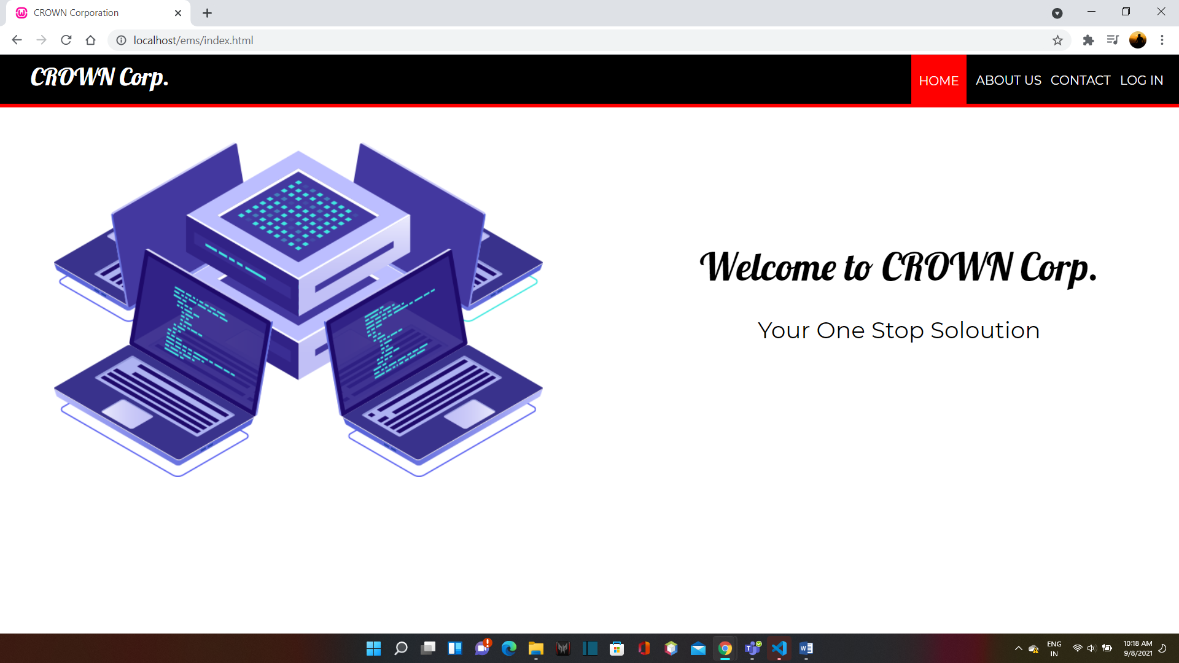

**Contact**

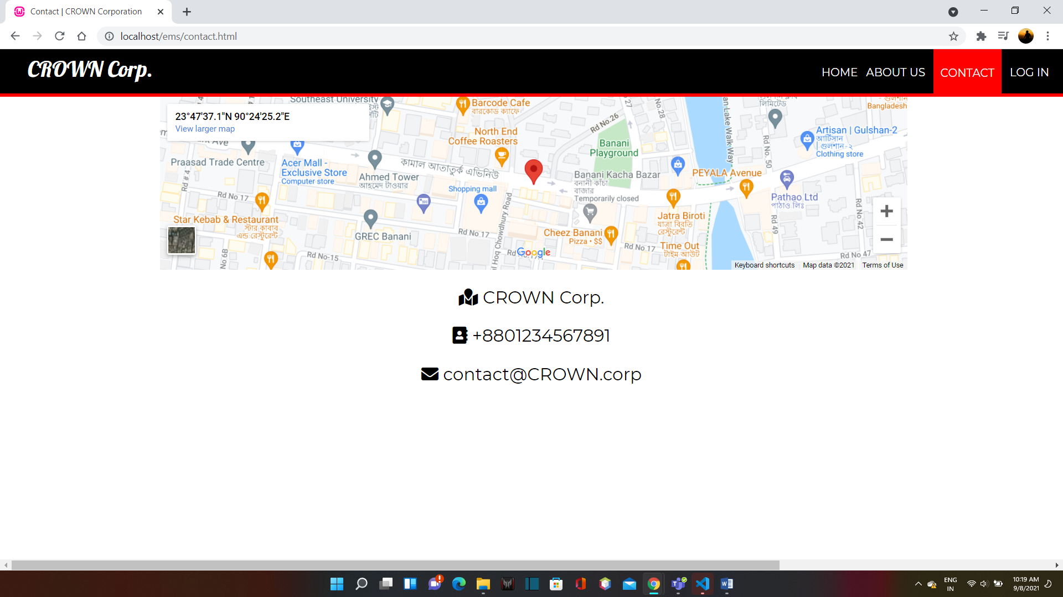

**Admin Login**

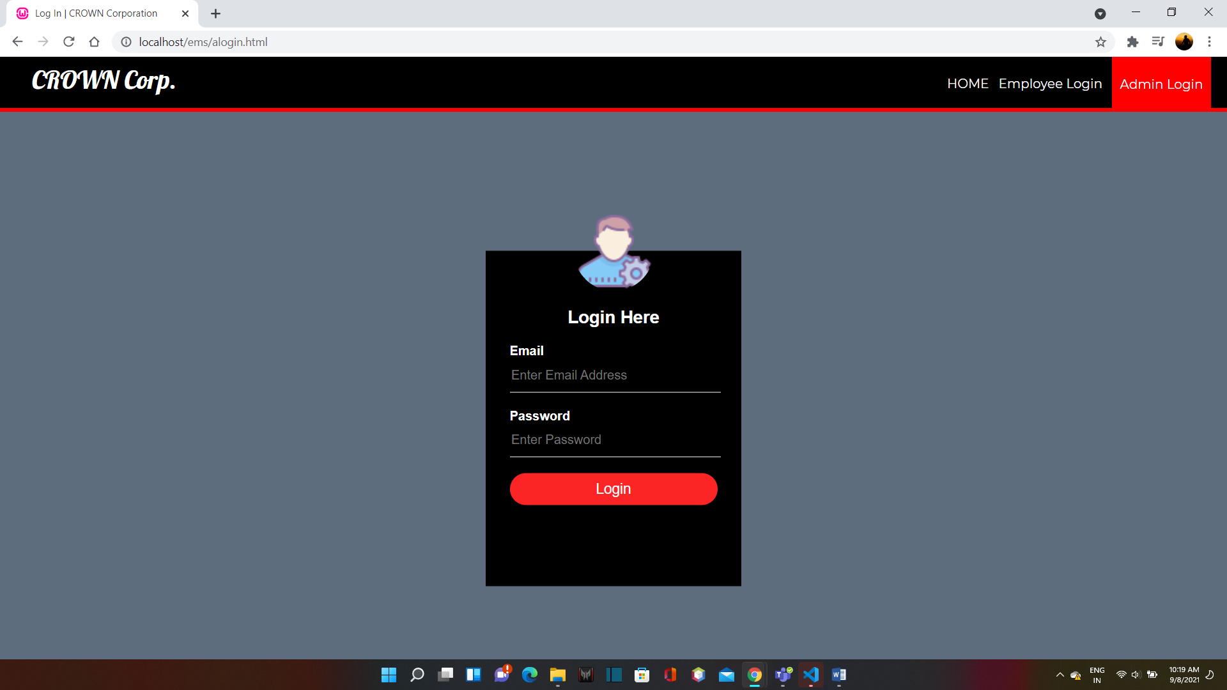

**Admin Home**

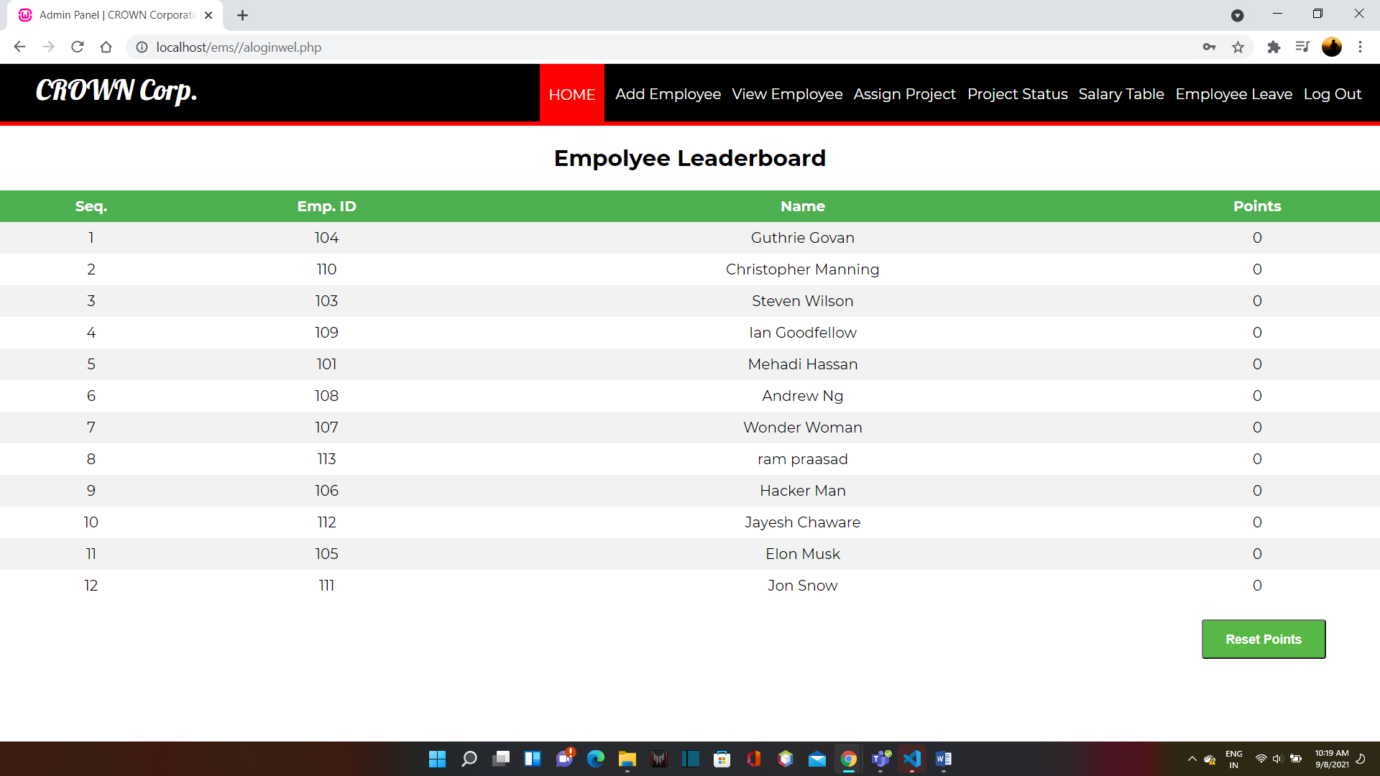

**Add Employee**

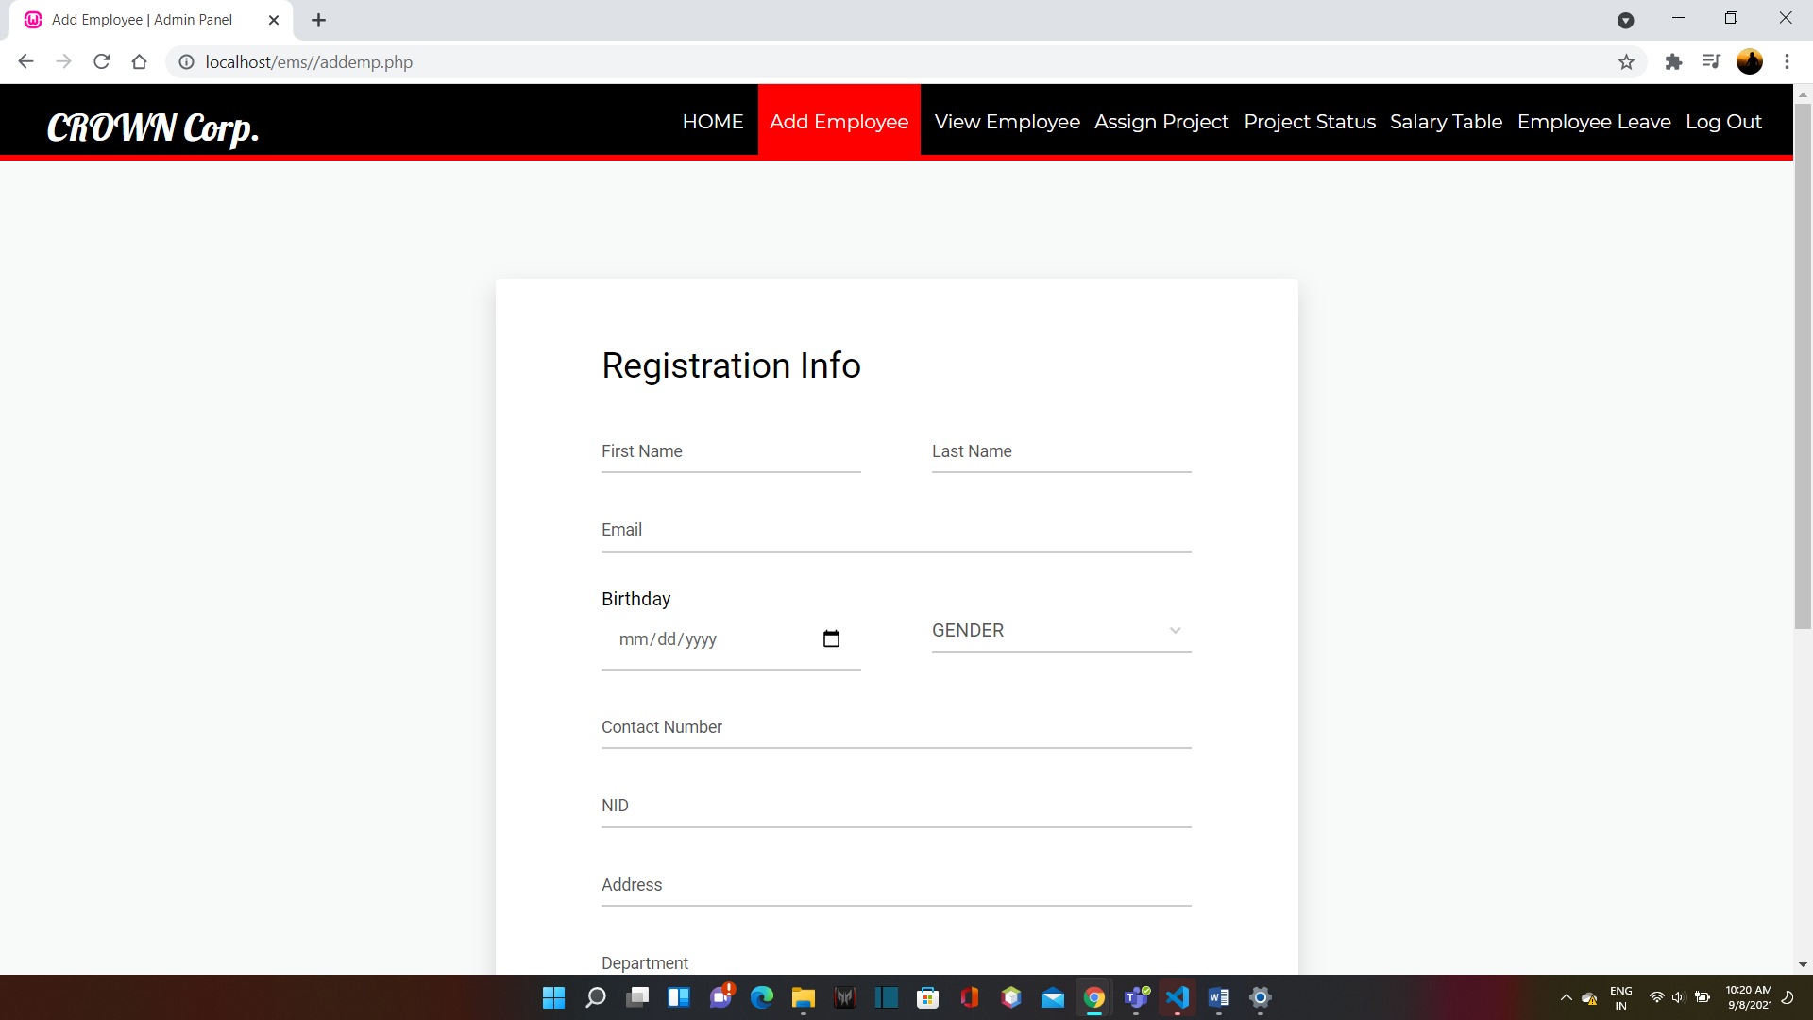

**View Employee**

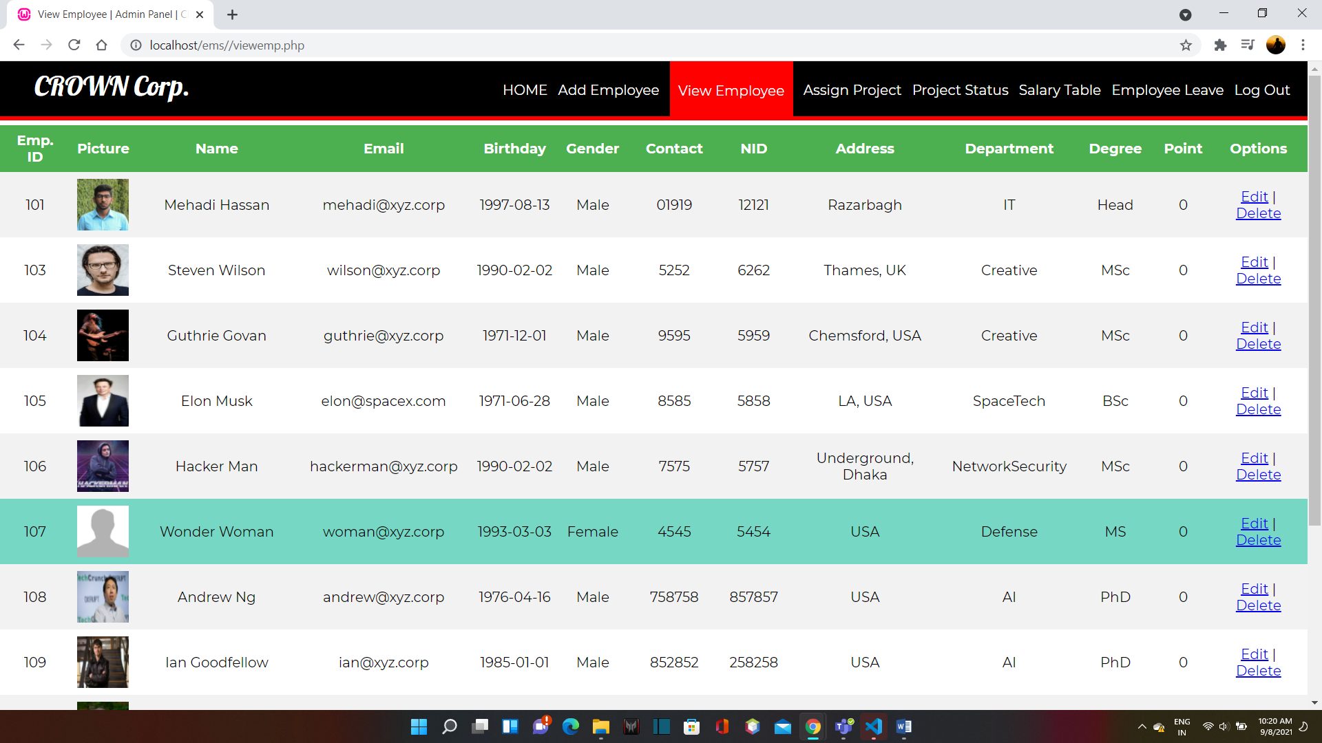

**Assign Project**

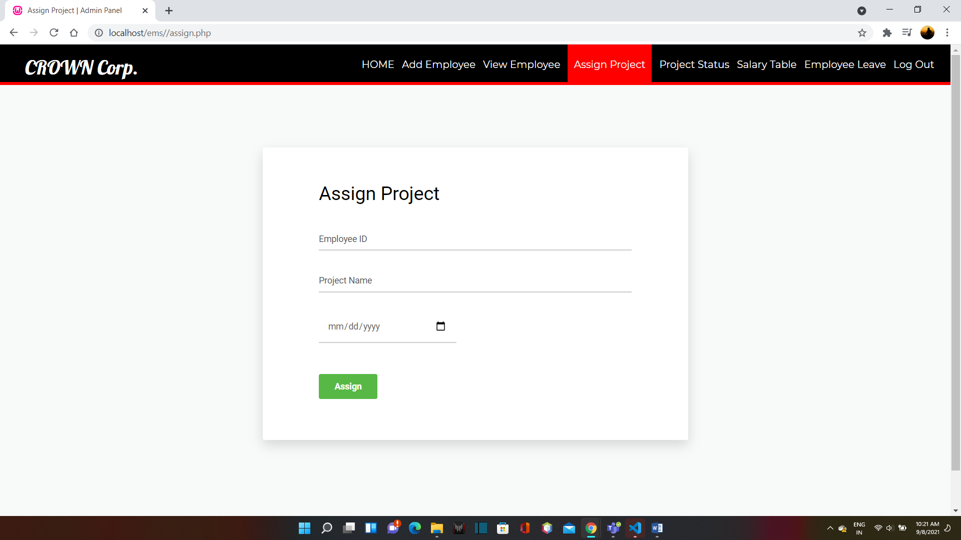

**Project Status**

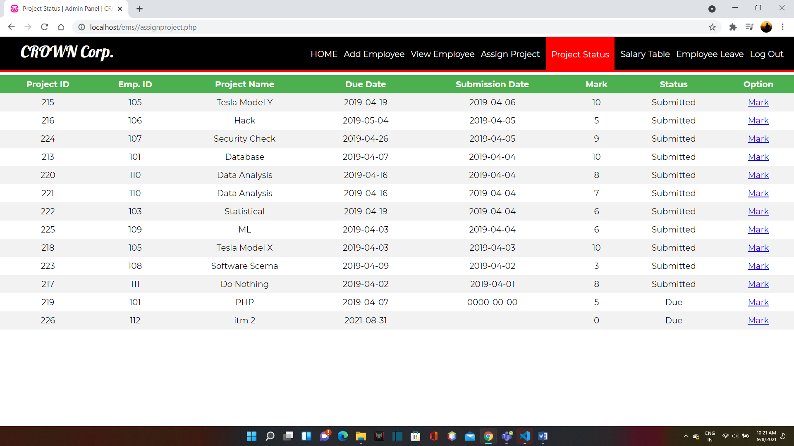

**Salary Table**

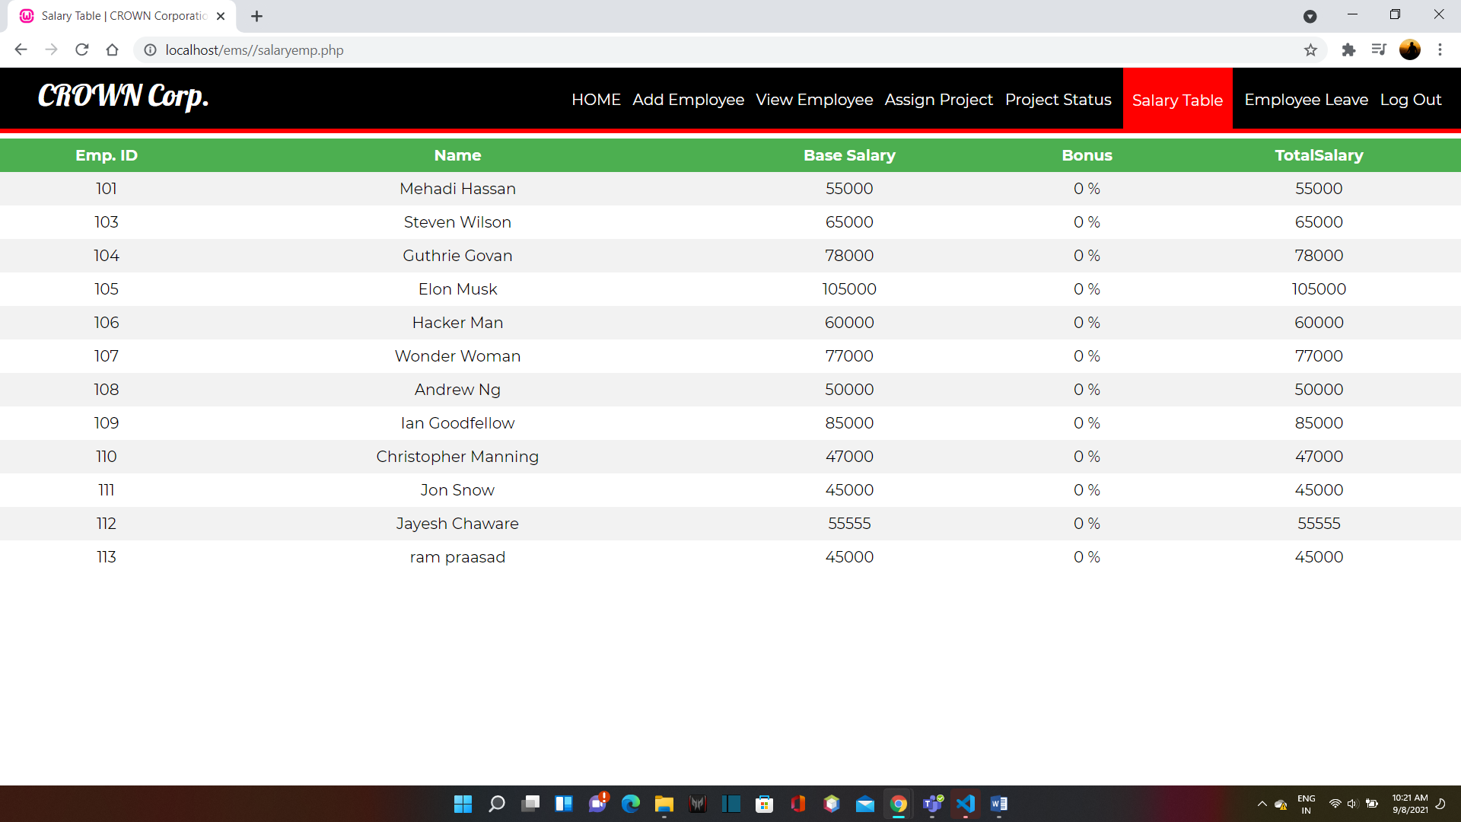

**Employee Leave**

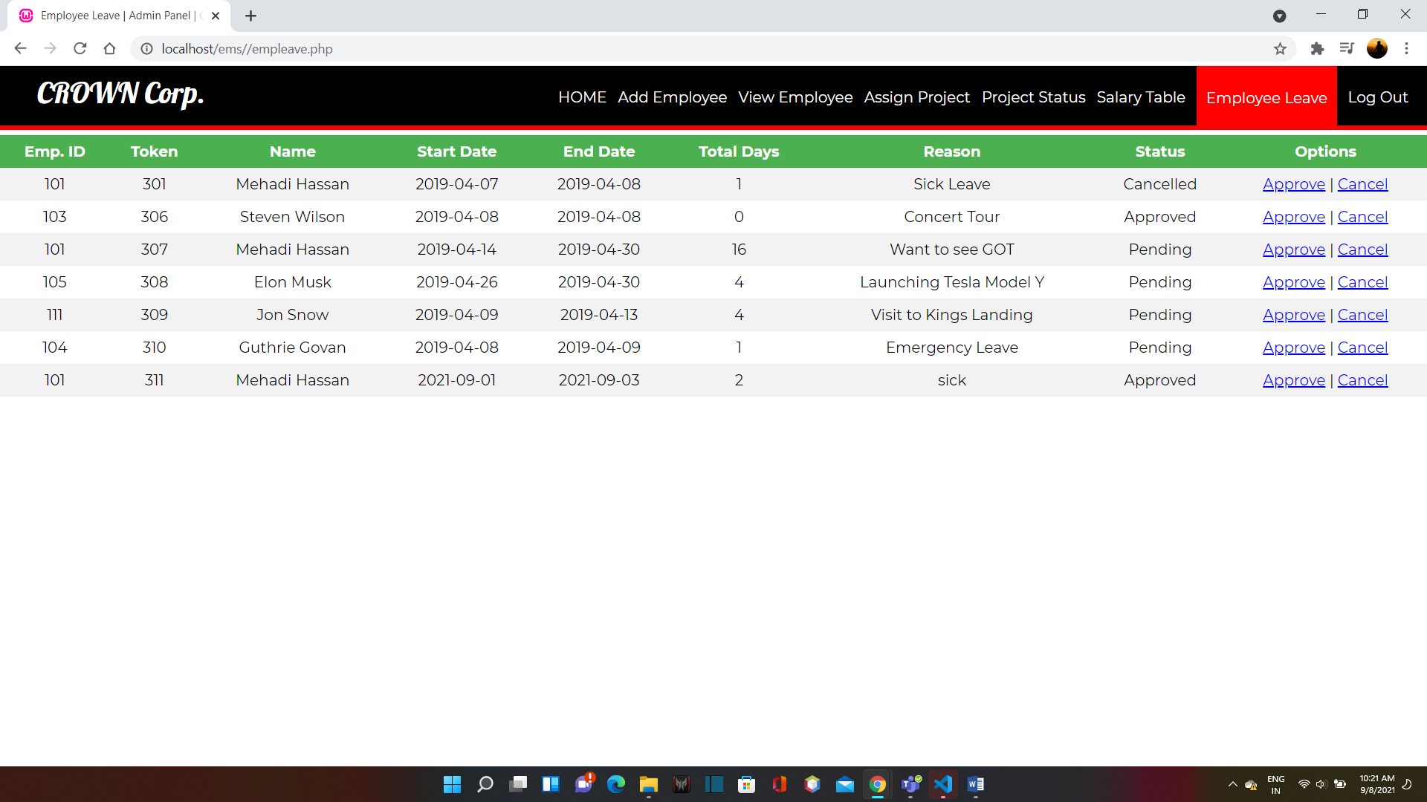

**Employee Login**

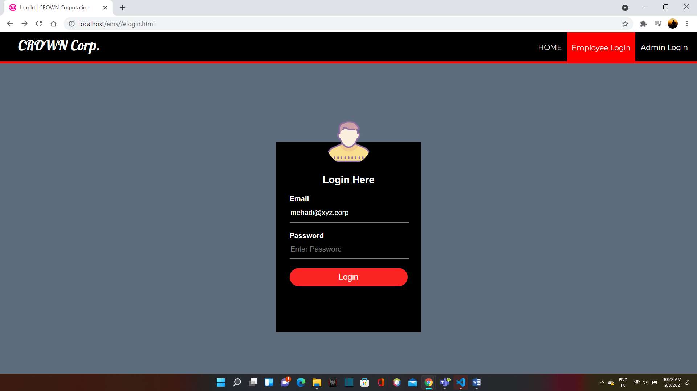

**Employee Home**

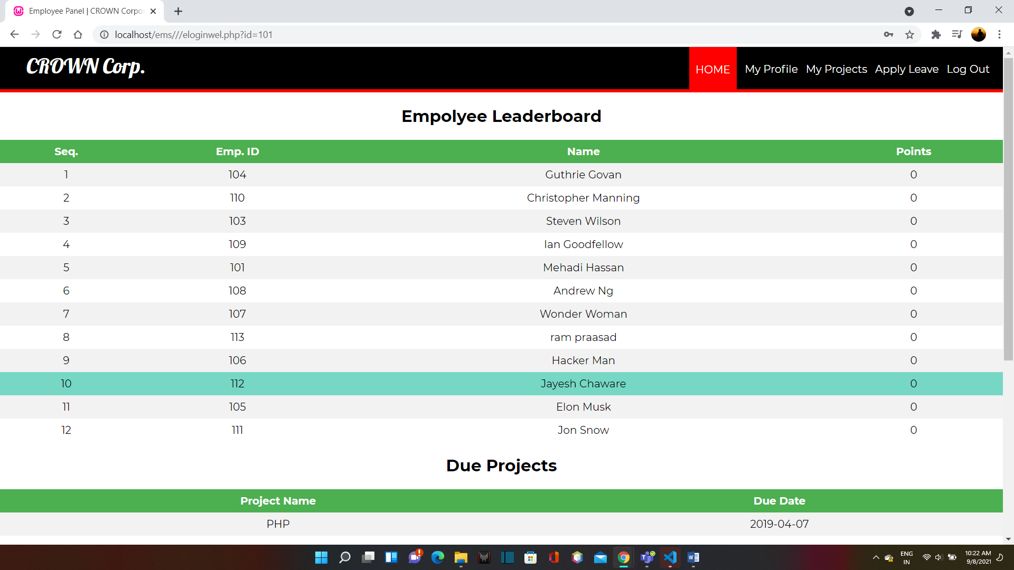

**My Profile**

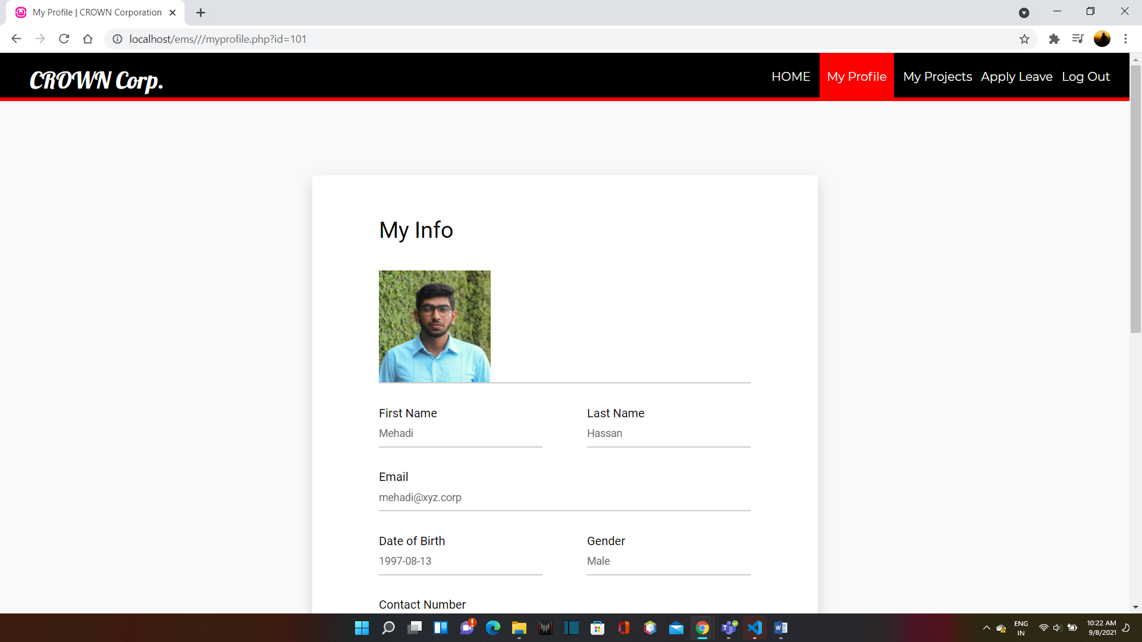

**My Projects**

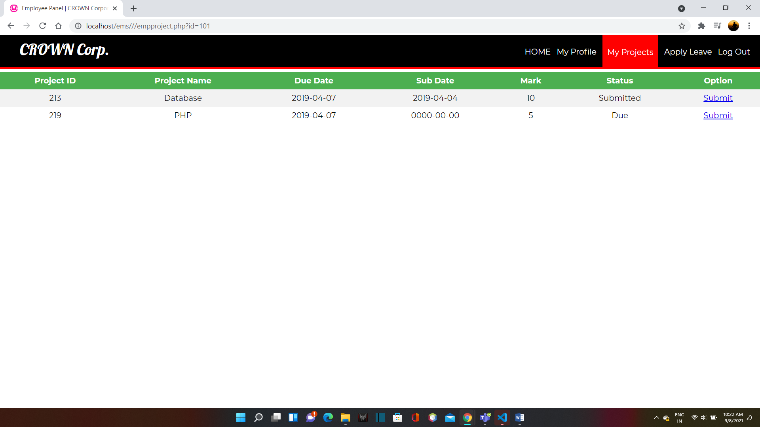

**Apply Leave**

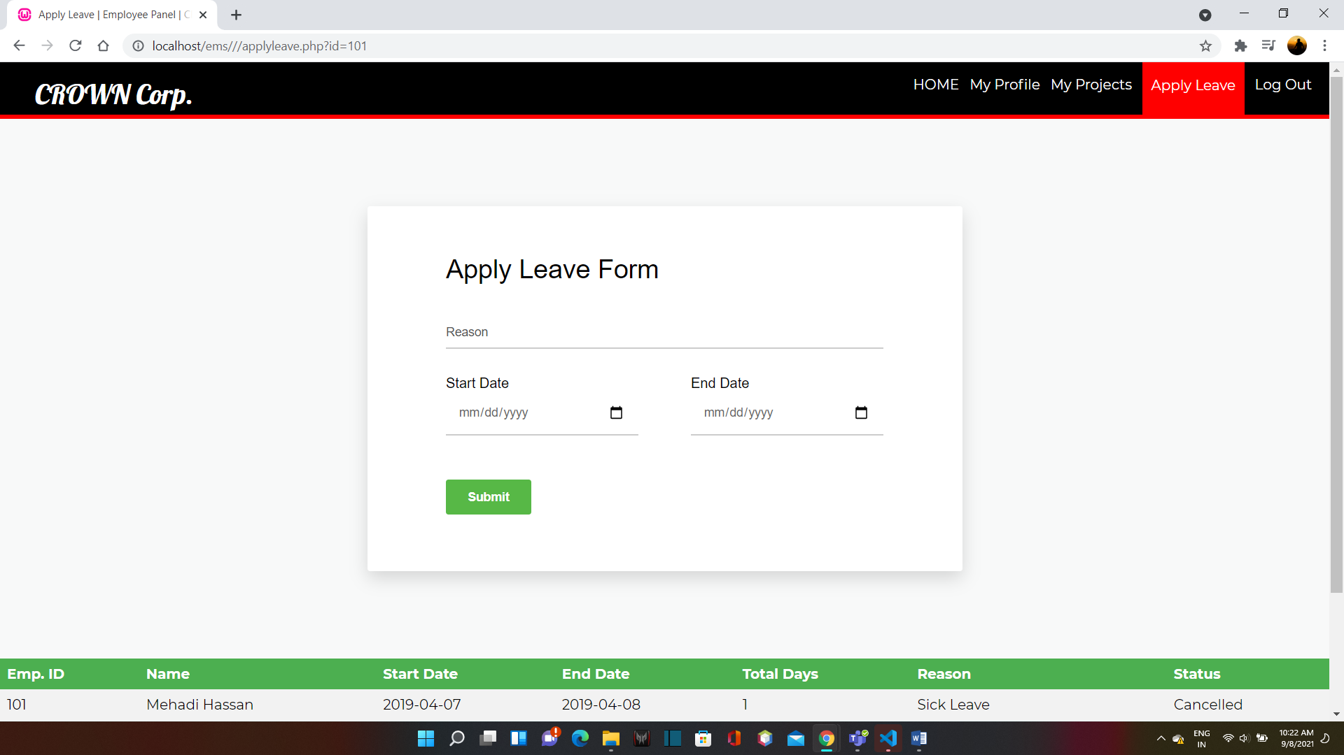

***CHAPTER – VIII***

**SYSTEM**

**Testing**

**SOFTWARE TESTING TECHNIQUES:**

Software testing is a critical element of software quality assurance and represents the ultimate review of specification, designing and coding.

**TESTING OBJECTIVES:**

1. Testing is process of executing a program with the intent of finding an error.
2. A good test case design is one that has a probability of finding an as yet undiscovered error.
3. A successful test is one that uncovers an as yet undiscovered error.

These above objectives imply a dramatic change in view port.

Testing cannot show the absence of defects, it can only show that software errors are present.

There are three types of testing strategies

1. Unit test
2. Integration test

3. Performance test

**Unit Testing:**

Unit testing focuses verification efforts on the smallest unit of software design module. The unit test is always white box oriented. The tests that occur as part of unit testing are testing the module interface, examining the local data structures, testing the boundary conditions, execution all the independent paths and testing error-handling paths.

**Integration Testing:**

Integration testing is a systematic technique or construction the program structure while at the same time conducting tests to uncover errors associated with interfacing. Scope of testing summarizes the specific functional, performance, and internal design characteristics that are to be tested. It employs top-down testing and bottom-up testing methods for this case.

**Performance Testing:**

Timing for both read and update transactions should be gathered to determine whether system functions are being performed in an acceptable timeframe.

***CHAPTER – IV***

**Conclusion**

EMPLOYEE MANAGEMENT SYSTEM has many powerful features and is certainly more than a "simple" diagramming tool. With its support of MDA (Model Driven Architecture), it is more aimed at people using UML in an intensive way and with some code generations objectives than for simply drawing diagrams to document requirements. However, using EMPLOYEE MANAGEMENT SYSTEM just as a diagramming tool work fine, especially on Windows as the tool is built with Delphi and might execute faster than the Java-based tools. Modern world is computer world where the things have to be done promptly that requires optimal resources and optimal methods. Due to this inevitable requirement, computerization of each and every sector in the main stream is must, so that it can be held itself in the race. Few eye catching features of our project are its simplicity, accuracy, and its user friendly interface. Our software incorporates all the features and facilities provided by the Visual Studio software. This project has been developed to manage the entire working of the Curfew Pass administrative. Our software simplifies and replaces all the manual effort and the paper works done by the administrative to a completely electronically environment. Hence both the user and the administrative are at their ease. The user is serviced at his footsteps wherein he just types in the request and he is just a click away. We would like to convey our sincere gratitude and thanks to all, who stood as our backbone, in designing, formatting and helping us in executing this project successfully.

***CHAPTER – X***

**Bibliography**

**For PHP**

* <https://www.w3schools.com/php/default.asp>
* <https://www.sitepoint.com/php/>
* <https://www.php.net/>

**For MySQL**

* <https://www.mysql.com/>
* [http://www.mysqltutorial.org](http://www.mysqltutorial.org/)

**For XAMPP**

* <https://www.apachefriends.org/download.html>